The Development of a College Engineering Organization and the Inevitable Transition of Power

A Handbook for an Engineering Student Leader

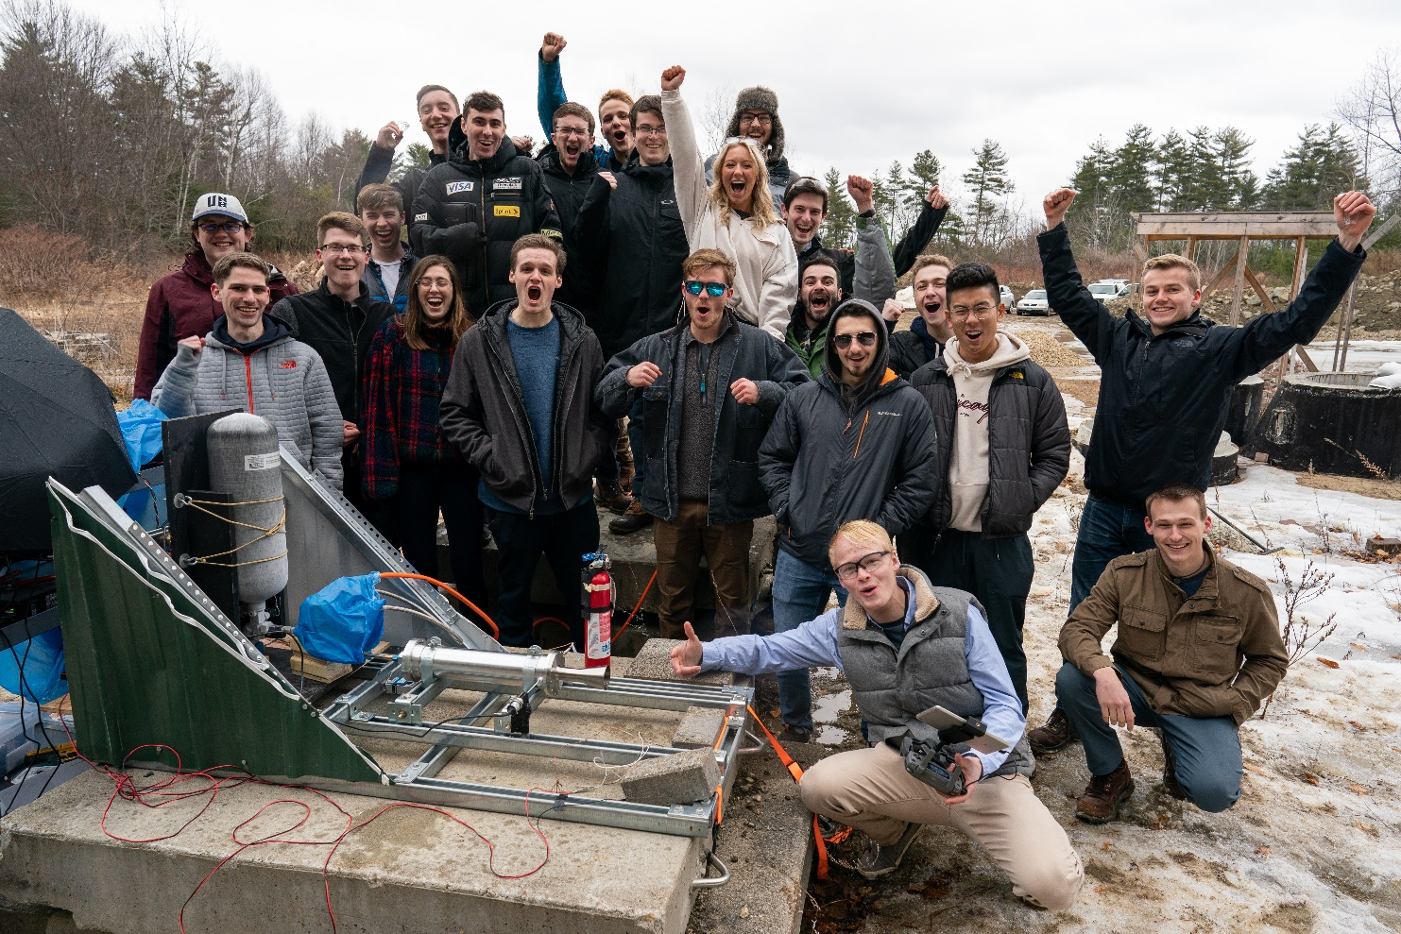

Charlie Nitschelm

Contents

Acknowledgements 4

Preface 5

Ignition 7

The Signifiers to Start 8

The Fundamental Questions 8

A Quick Statement on Leadership 9

Working with the Powers 10

Where to Now? 10

Building around a Project 11

Preparing the First Meeting 11

Running the First Meeting 13

Identifying a Growable Team 14

Altering the Goals Slightly 15

Primary Objectives after the Initial Meeting 15

A Quick Statement on Management 16

Spark to Throttling Up 17

Throttle Up 18

Growing your Leadership Skills 19

The Fundamentals of Leadership 19

Motivating Students 24

Creating a Leadership Board 25

Learning to Manage a Team 26

The Fundamentals of Management 27

The Life of a Project 35

Managing Engineering Students 43

The Art of Meetings 45

The Pre-Meeting Prep 46

The Actual Meeting 47

Post Meeting 48

Increasing your Budget Sustainably 48

Who should be involved? 49

Who to contact and how? 49

A discussion of grants 50

Incentive the team 51

Final notes on Fundraising 52

Expanding your Membership 52

The Club Fair 52

Class presentations 53

Final Recruitment Advice 53

Growing the Culture 54

The Importance of Respect 54

Pride in your Appearance 55

How Vision and Mission play a Role 55

The Search, Retention and Value of a Home 56

Final Thoughts on Culture 57

Orbits and Transfers 58

Sustaining the Organization and Culture 59

Policies, Procedures and Shared Understandings 59

Waste Removal 62

Fortifying the Culture 63

Facilitating Change 63

Communicating and Implementing Change 64

External Effects of Change 65

De-Orbit and Land 66

Transitioning of Leadership 67

The Factors of Success 67

The Banquet 69

Closing your Project 70

Appendices 74

Appendix A 74

Appendix B 75

Appendix C 82

Appendix D 89

Appendix F 93

Appendix F 96

# Acknowledgements

Although the public often directs their praise and admiration to the founder or the leader of an organization, they are often just a small, single puzzle piece in a far-greater picture. There are scores of people that will affect the initial birth of any organization, some internal to the group and some external. If I were to thank each individual person that positively affected the creation of the University of New Hampshire (UNH) Students for the Exploration and Development of Space (SEDS), my college engineering organization, it would fill a couple pages. I could also say the same about the people who created barriers and problems to plow through; all of which are crucially needed to learn, grow and teach the principles presented in this handbook.

To Kevin, Scott, and Sheldon of the UNH College of Engineering and Physical Sciences (CEPS) Technical Service Center for putting up with my constant questions and allowing the organization to expand and feel like home for so many students.

To the staff within the mechanical engineering department and CEPS including Kelly, Pam, Sheri, Dean McCrone and Dean Zercher.

To Todd Gross, for being our advisor and a constant no-nonsense confidant for me.

To Reilly, the first senior project and connected alumnus.

To Ross, Grace, Silas, Lucas, Carly, and Zach who have been members and contributors since nearly the beginning of UNH SEDS whose opinions I respect greatly.

To Alice, Jeff, Alex, Dylan, Max, Cornelis, and Porter for giving me hope that the club has a stronger future with me out of it. You will make us all proud.

And to Thomas, the best VP I could ask for and my dearest friend. May we continue to grow and make a difference in the space industry.

# Preface

When I was a freshman at the University of New Hampshire (UNH) in 2016, I was upset and discouraged by the state of the engineering organizations available for underclassmen. Yes, freshman could join the teams, but what did that really entail? They were made up of entirely or primarily senior mechanical engineering students using it for credit on their senior design project. Each year, a different group of non-passionate seniors filled the groups just to satisfy a graduation requirement. What is the fun in that? What actual learning, engineering or otherwise, can be done in less than one year? What kind of growth can be fostered on the organizational level with that system? I could not settle for this, so I decided to go the route of creating one. I founded UNH Students for the Exploration and Development of Space (SEDS), one of now 80 chapters nationwide that support the development and growth of students so that they are competitive to join the space industry. Although my team is a space/rocket focused organization, the learning in this handbook is universal to any type of engineering organization (fire and free flight does attract an intelligent and driven crowd, though; I highly recommend it.).

UNH SEDS started with a few people passionate about the future of the space industry. We all knew the impact that the industry has on and off Earth. During its first academic year (2017-2018), we were 6 strong with around $1,500 of total funds to work on basic rocket building and simulating techniques. Our work won second place at the UNH Undergraduate Research Conference, which gave us recognition on the college level. During its second academic year (2018-2019), we grew to 13 strong from 5 different majors and every class with around $4,000 of total funds. We started work on New Hampshire’s first hybrid engine entirely built by students. In its third year and my final year (2019-2020), the organization grew to the largest and most powerful engineering organization on campus with 39 active members from 8 different majors and every class with around $20,000 of total funds to work on a full hybrid powered rocket to compete in the Spaceport America Cup in June, 2020.

This handbook contains all the lessons and advice I can give after starting my own college engineering organization over the course of 3 years. I have run into countless failures and mishaps, and just a handful of crucial successes. Although all my experiences led to the growth of me as an engineer and student leader, this handbook serves to help you navigate the web of creating your own organization to help mitigate the pain points and save you from the countless hours of struggle that I had to experience.

I owe everything I have to UNH SEDS. I owe my entry into the commercial space industry through the Matthew Isakowitz Fellowship Program. I owe my career path that lead me to work at top rocket launch companies in the U.S. including interning at Rocket Lab and working full-time at SpaceX after graduation. I owe most of my applicable learning during university. I owe all the connections I made in the industry that lead me to my opportunities. I owe my general identity and personality. Most importantly, I owe some of my dearest and closest friends to UNH SEDS; they are my second family in life.

This handbook will read like I am speaking to you, constantly drawing up specific examples from my own experience with UNH SEDS to help illustrate the major takeaways I want you to come away with from each sequence and section of the handbook. Although I recommend a full read-through first and then reference sections when needed, you can also just read certain sections that you are looking for help in. Although this might help alleviate mistakes and failures you might have made without this handbook, you will still see failure and regret. Do not let that discourage you; plow through problems and take 100% ownership of your organization and the work it produces. Now, let’s get started.

# Ignition

The purpose of this section is to review the thoughts, actions, and realities of what it takes to start a college engineering organization. This sequence in a college engineering organization’s lifespan typically lasts from initial conception to less than 3 months. We begin this sequence with Signifiers to Start which walks you through the fundamental questions you need to ask yourself before embarking on this journey. We will then move to Building Around a Project, a crucial step to build a base of work and culture needed so you can then go about Identifying a Growable Team. By the end, you will have gone through many struggles but will have created the start of a blossoming college engineering organization.



## The Signifiers to Start

Starting an organization is hard. It is not the type of hard that you experience from difficult homework, assignments, or labs, but one that sticks to you, constantly on your mind. You don’t get instant appreciation or gratification. You don’t even get a grade! You will make sacrifices to your personal life. You will have many late nights. You will need to sober up a bit and have some free weekends. You will need to reduce waste in other areas to free up time. The organization will become your top priority, not necessarily because you need it to, but because you will want it to be. Sounds terrible, right? But it can be the most rewarding thing you have done up to this point in your life. It could turn to be your driving force in life, guiding you to a path of success and happiness. If you haven’t been scared off yet, you might be up for this. Let’s get to the critical questions to ask yourself to provide a framework for yourself on your motives and abilities.

### The Fundamental Questions

The first question to ask yourself is why are you interested in starting an engineering organization at your school? It could be to gain the experience needed to land an internship or job that you desire. It could be because you want a chance to feed your passion for the type of engineering group you want to start. Are you just bored and want to make something for yourself to do? All of these are acceptable reasons and are very important to know internally for yourself as you sprint down this path. The fundamental purpose you have for the organization will pave the outcome you will create. Personally, the former reasons are the strongest driving forces to have and they are usually intertwined with each other. Having a dream outcome for yourself after school that naturally feeds your passion to your organization can motivate and drive you to work tirelessly. Write down your reasons personally and keep them close. Not only will it create a base for yourself to revisit when times get tough, but it will also create an amazing relic to leave the organization once you leave. I did this when I was starting UNH SEDS and I recently shared that document with the team almost three years later. It was a powerful message to give to the growing leadership of the team. I teared up when I first saw it after so many years because I did achieve what I set out to do with UNH SEDS.

The second question to consider is if the timing of your organization aligns with growing societal interest and if it fills a niche at your school? Don’t try to start ‘another’ racecar team. Don’t try to start a general engineering club that changes subject every semester. You want to create an engineering organization that can build each year and retain folks passionate about the areas you work in. What also impacts the amount of success you can have is overall interest in the industry. I was very lucky. I fell in love with rockets after I witnessed a booster landing of a SpaceX Falcon 9. There were no rocket/space engineering organizations on campus. I read that the commercial space industry is expanding at an exponential rate. I struck a win on all these categories without even thinking about it during the time. What is unique about my university, UNH, is that there is not an aerospace engineering major option, so the students at the school are naturally less space oriented compared to students that go to the schools with aerospace programs. But what I did not suspect was to find students that really wanted to get into space after already choosing to go to UNH, just like myself. These students were not just interested, but the members that gravitated to the club had a real love and passion for the power of space. UNH SEDS was the only option to work on space projects with other students. As you explore all the routes you can take with your organization, please consider all these factors as, when they are in your favor, they will help you greatly.

### A Quick Statement on Leadership

A very common concern for students looking to start an organization or take ownership of one during yearly elections is that they think they are not capable of leading. It is true that some students struggle to speak publicly or lack fundamental qualities that enable people to follow them. That is a huge minority, though. Leadership is a learned skill and it can be grown, which is why there is an entire section within the Throttle Up sequence that explores this topic. This concern should not alter or demotivate you at all at this point. To become good at something, you must both start doing it and do it all the time. Let this be your start and let the rest of your college career be doing it all the time. You must have the energy to learn it, though. Are you discouraged by failure or are you driven by it? A new leader will see failure a great deal more than any success, so prepare yourself mentally to handle that and move forward from it. It took a great deal of failed Falcon 9 landing attempts to finally have a success, and the same will go for growing your leadership skills to create a well-functioning team. I specifically remember sweating through my shirt at the armpits leading up to the first UNH SEDS meeting with 9 interested people. Now I have no problem talking to a room of 40 people with confidence. Public speaking and engagement are now a strength of mine.

### Working with the Powers

The largest headache to starting an organization and remains a pest throughout its life is how to navigate the ‘Maze of Power’. The ‘Maze of Power’ is the web I use to define the different people to contact given the question or ask you have. I remember specifically one time I had a question that required 7 forwards in an email chain to get to the right person to help me. Once learned, though, you will be able to move quickly when finding answers at the university level. You should give a significant amount of attention to the people you interact with and what they can do for you so you can easily call on them with clarity. Faculty and staff at your university will create natural roadblocks for you as you become a student organization, but stay determined to connect with them. Remember, people working at a university are not there for the money but are there because they want to make an impact on the next generation of workers. They are on your side. They are simply busy and want to ensure that you are worth their limited time. They are some of your biggest assets, and they are responsible for fundamental growths of your organization that is often overlooked. Get to know them and understand their imperatives. Take time out of your day to appreciate what they do, and constantly thank them for their efforts. This is crucial to setting up an organization during its initial beginning and carries forward throughout this entire handbook. Always be thankful of the people that help you and appreciate them publicly and privately whenever possible and appropriate.

### Where to Now?

So, you have asked yourself some fundamental questions and might be itching to get started. When I got this idea, I could hardly sleep. The excitement is great, and it should drive you. It is also important to keep it controlled and tamed. My excitement made me move quickly, but I made some mistakes on the way that upset some core people who impact the organization. Be respectful and be nice. A pro-tip is to always re-read emails and ensure you are never telling them what to do but suggesting or asking. Make them understand why it is something you need and how their help will affect what you want to do for the development of your organization. People who are doing you a favor don’t like to be told what to do. I rushed and moved so quickly that my virtual presence came across as commanding and unappreciative which is exactly what you should avoid. Now you must build your organization around your first project

## Building around a Project

It is a very common mistake to attempt to build a group of students first and then you build a project around the current group. That does not work. You must identify the broad goals of the organization with a more detailed view for the first year based purely on what you want to do. Once that is done and worked out clearly for yourself, recruit individually with friends or classmates that seem interested by word of mouth. Alter your plan a little to fit those handful of people to get on board, and then stick to it. Once you have that overarching schedule, including short and long-term goals, now you can build a group around it. Some students won’t be attracted to what you and your handful of first recruits want, but that is okay. You aren’t here to satisfy everyone, because then you will satisfy no one. Allow your group to start small with a focused goal. Only a handful of students will make an impact to the organization the first year, so you might as well keep the work done something you and your most committed members are extremely passionate about. Once some work is produced that is exciting, more and more students will want to get involved and the scope can increase. For UNH SEDS, I told the group I wanted to launch 10 rockets using commercial, off-the-shelf engines and simulate every single one using MATLAB and compare that to the experimental data of the flight. It was a great project to build a team around, and it got some core driven people excited to get started. I had a plan, and people appreciated that I had a compass to lead the group in a certain direction.

### Preparing the First Meeting

Now that you have the framework of the organization and a small handful of interested students, it is time to make an exciting presentation to share to a larger, open audience. Select one or two of the already interested members to help you with this, including helping make the presentation so it is grabbing. There are three things that need to be done before the introduction meeting to get people to come:

1. Attention-grabbing flyers
2. Emails to the students
3. Obtaining an immense amount of pizza.

Make informative, to the point flyers to post everywhere around the academic buildings that draw the right crowd for your group at least a few days in advance. Ensure that if you need permission to post flyers that you’ve obtained permission to do so. Make it as simple as you can including the when and where it is, why students would be interested in the content, and that there is free pizza. Pick a room to meet that you can reserve through the school and make it a room most people know of. It shouldn’t be in a non-engineering building, but somewhere engineering students already hang out in. Have it at night to avoid class schedules; 8:00 pm is usually a great start time for organization meetings. If your university has specific bar nights during the week, like mine does on Tuesday and Thursday, avoid those days as that will limit the amount of 21+ members that will come. See Appendix A for UNH SEDS’ first flyer back in early 2017.

The next task is to get direct emails to students about the meeting that is to the point so an interested student will want to learn more. All schools do this differently, but usually the individual departments have ways of mass communicating with their students, which is the route you should take. Approach in-person each department that you want to get an email out for and connect personally with them. Follow-up with the email you want sent and confirm they sent it out over the next couple days. Remember to say thank you for what they do for you! From my experience with UNH SEDS, the emails do the most for getting students to come to your first meeting, so ensure that this is done well and in good time to give students a chance to fit the meeting into their busy schedules.

Food is extremely important as you probably know as it is needed to stay alive. Having it for the first meeting is a great incentive for somewhat interested students to come and listen to you. As this costs money, it is useful to reach out to the school to ask if they can fund this initial meeting. It is likely that they will as schools want to support students taking leadership roles outside of the classroom. Always remember to be respectful and nice. Tell them why this organization is important to you, and why people will come. How will it impact the school? Be passionate and driven as people naturally want to help young students that are doing things they love. I have personally found that to be a primary way to influence your surrounding faculty and staff to do things for your organization. Everyone looks up to people who do things they love to do.

### Running the First Meeting

Practice presenting before the meeting and come with confidence. Like me, this will be the first time you are presenting this idea to a large crowd, and it might be the first time you speak openly to a bunch of strangers. Do not become discouraged if only 7 people show up. Remember, you only need 5-10 members to hit the ground running, so quantity is not the goal, quality is. Be open, transparent, and honest. Introduce yourself to the group as first impressions are key, especially if you are presenting to a group of total (or almost total) strangers. Go in more detail about what the group is about, what you want to do, and the next steps after the meeting. Stress the outcomes that can come from this organization, and how they can benefit from donating their limited time to it. Is it an internship? Is it connections in the industry? Next steps should not be another presentation meeting, but conversations that start your project. They are there to work on cool stuff, not talk about non-value-added things. The quicker you can get to progress on something, the faster and stronger you will expand. But remember, for your organization to be effective, it must at heart be a learning organization. Stress that, as the interested members need to know the projects you do are to learn, including failing and hopefully succeeding. UNH SEDS had more rocket failures than successes, but man, did we learn a lot. By the end of the year, we knew the ins and outs of designing, building, and launching small rockets. If there was a failure on the field, it came to the point that we would know the reason for the mistake and how to solve it before heading back to the shop. Failure is always an option as a student organization, as long as you never make that mistake again and learn from it.

The first meeting is not just to present your goals to people, but also used for you to meet and gauge the interest of each person attending. Make it a goal to talk to each person, have them sign in with their contact information, and write notes down on each person. Get to know them and why they took time out of their night to come to your meeting. This will help you to Identify a Growable Team.

## Identifying a Growable Team

T.J. Sullivan, author of Motivating the Middle, defined the terms top-third, middle-third, and bottom-third members in a college organization. What he means by these terms is that each college organization shows a common trend of having groups of students with different levels of commitment. “Top-third members do most of the work. They are the visible, busy leaders. If their hands are not actively doing something for the group, their minds are likely thinking about the next event, meeting, project. They run for office. They step up when there is a need (Sullivan).” His work was done for the broad college organization, and I have found some of his definitions in need for minor tweaks for college *engineering* organizations. Instead of breaking them up into thirds you see more of a top quartile, middle half and bottom quartile. It is more of a trend to see a fewer amount of students take the top role of a college engineering organization, with a larger concentration being in the middle, meaning “a middle-third member is happy to contribute to the success of the organization, but is much more likely to be a supporting player than the MVP ((Sullivan).” I will use my variation of Sullivan’s definition of types of members in an organization for the remainder of the handbook, but the general meaning of the types of students are the same.

With that in mind, a primary focus for you is to seek out and retain potential top quartile members. Those members, which could be only 2 or 3 students, could be your driving forces for the organization. Your secondary focus is to retain any middle half members and keep them involved as much as you can. It is useful to pair an obvious top quartile member with a middle half member during the first year to help split the load of keeping a solid base of members. If you are a senior already and looking for those next people to take on the organization very quickly, you will find the leaders in your top quartile members. I suggest only making an organization if you have at least 2 semesters ahead of you. Creating a growable team that will want to grow without you can take some time. In my experience starting an organization as a late freshman, I had three years to grow the organization, and only in my last year did I really become convinced it would continue without me and my founding members. Of course, if I was older, I would have put more focus into cultivating that next generation of leaders sooner so I suspect you can get that confidence quicker than I did.

### Altering the Goals Slightly

The entire goal of the first meeting is to gain interest from as many driven students as possible. It will be somewhat clear who the top-quartile and middle-half members are, while the bottom-quartile members will maybe show up to following general meetings but will rarely contribute to the actual engineering or general discussion. The top-quartile members will generally ask questions and stay after any meeting to talk more personally. Once you have some interest from the first meeting and have the next steps planned and scheduled, it is time to start thinking if anything needs to change from your initial thoughts of the organization. As it grows, it will become increasingly more difficult to institute large change during the first year, so now is the time. Once you are feeling good about the next planned meeting and the stuff you and the top team members want from it, it is time to grow the organization with the members you have. I personally did not have to change my initial goal of the organization, but other teams I have met had to do a shift to include some top-quartile members to become invested in the organization’s mission.

### Primary Objectives after the Initial Meeting

What people or groups can help you at this point? It is imperative to become a student organization with the university and your college of engineering if possible. Great resources can come from this including help from faculty and staff, money, and most importantly, possible organizational space to do your work and have meetings. It is also a requirement to have an advisor at this stage, so be sure to meet with some professors that align with the organizations interests or a professor that seems very willing to help. Energy is the most wanted trait of an advisor, not expertise in the subject. This might seem counter-intuitive to some of you, but it really isn’t. There are many professors that will be open to assisting on the technical projects you take on, but the organizational advisor should be someone who has the energy and want to help. They should share the same passion as you and be excited to work with you on the organization. For example, UNH SEDS did not select a faculty that worked directly on space and NASA research, but someone who was personable and had the time to dedicate to the group when asked. That is the most important attribute for your advisor.

Permanent room space is a rarity for organizations, but with energy it can happen. I personally fought to get room space, and once I got a small section of a room, I made it my duty to make it feel like a home base for the group. Take it slow, and don’t ask for a lot off the bat. You might think you need it, but let your organization grow until it becomes apparent it just needs more space. UNH SEDS grew from that small table to nearly an entire lab room over the course of my three years, and I suspect it to take the whole room in the next year. I will talk more about the importance of a room in the following sequence.

Another objective as you narrow in on your organizations is to join a national organization that aligns with yours. There are many national organizations that can connect you to a national family of other students and young professionals. I personally found SEDS because I wanted a space-oriented organization and SEDS was a proven, great community that could immediately provide a base network of students driven by space.

It is also sometimes beneficial to reach out to other organizations at the school or at the community level that somewhat lie with your interests to gain initial connections with already prospering groups. I did not do this with UNH SEDS initially, but looking back, it could have helped a lot. Unfortunately, there are not a lot of space activities in New Hampshire, so it wasn’t much of an option anyway. Utilize what is around you as much as you can. People want to help you.

### A Quick Statement on Management

The most important advice on general management I can give you at this stage and at this section of the handbook is from a book called ‘Why Doers Do’ by David E. Wile. The author says, “people don’t change much,” which is a very important thing to understand on a deep level here. It took me quite a while to get this in my head and use it on the day-to-day with UNH SEDS. What this means is that it is not your job to motivate or inspire the students to join your club. Have them join because the work you want to do inspires and motivates them. People don’t change so try not to waste time pondering how to get more people interested. Work with what you have, and students will naturally want to work on it if it is meaningful and exciting. Do not forget that as you begin to start your projects. It is *your* job to take complete ownership of the project and do everything in your power to progress the organization as a team. If you and your small top-quartile members are driven and passionate, members will naturally drive themselves to work on things you deem important and show are necessary.

### Spark to Throttling Up

At this stage you should have determined the why in starting your organization and have created an initial base of interested members to get started on your goal and first project. It is now time to nurture that and not let the energy die down. If an organization stays static, it slowly dies. It is now time to Throttle Up and tackle the bulk of the content in this handbook as this stage is deep in potential roadblocks, failures, and insights. Let’s dive right into Throttling Up your organization.

# Throttle Up

The purpose of this section is to understand the growth, knowledge and action needed to Throttle Up the strength of your new engineering organization. This sequence in a college engineering organization’s lifespan typically lasts from 3 months old to less than 3 years. The learning objectives of this sequence though, in its root, is always applicable to all the future sequences of launching a college engineering organization. We begin this sequence with Growing your Leadership Skills, which will impart the fundamentals in learning how to lead people and motivate students specifically to rally around a common mission and vision. We will then move to Learning to Manage a Team, a fundamental skillset for starting and ending projects successfully all while correctly managing engineering students. That flows seamlessly onto a deep discussion on The Art of Meetings, a talk on Increasing your Budget Sustainably for the organization, Expanding your Membership to support that growth, and comes to a beautiful finale that wraps all these sections together in Growing the Culture of your organization.



## Growing your Leadership Skills

Leadership is a learned skill. As with any learned skill, it takes commitment, drive and passion to want to improve. Most importantly, it takes time. This section within Throttle Up tackles the topic of leadership. Why is it important? How do I become better? What is the purpose of leadership? How are students particularly led? Is there such a thing as a bad team, or is it just a bad leader? Hopefully this section will take you on a journey that provides insight on all these fronts, so you are able to navigate the large, intertwined web of leadership in a college engineering organization with more ease and insight.

### The Fundamentals of Leadership

The role of a leader is to provide a clear and communicated mission and vision to a group of people. They must take complete ownership of the happenings of the organization and is held accountable for everything the team does under their leadership. “Vision pulls people not only to take action but also to care about the outcome, to take personal ownership of it, and to bring their “A game” every day (Comaford-Lynch).” Members of an organization *need* to understand what their work is adding up to. It is up to the leader to provide that framework so at every moment each member can clearly recite the mission and vision of the group. If it is not apparent to all, then it will drastically reduce the performance of the team. During the Apollo era, Kennedy was touring the facilities at NASA Kennedy Space Center when he ran into a janitor. The President asked what his job was where the janitor swiftly replied, “Well Mr. President, I am helping get a man on the moon.” Although I am paraphrasing heavily, it illustrates the mindset that was adopted by the American people during the most driven times in space. A second example of this is my own personal story, but I am sure many people have shared the same experience. At SpaceX in Hawthorne, I made it my mission to ask 5 random people during a tour what they were doing at SpaceX. They all had the same answer, regardless of their position: “I am working to get the first humans on Mars.” Talk about a driving force to contribute your time to that company. I don’t expect such lofty missions from your organization, but hopefully you get the idea of the importance of them. This also brings up a favorite quote of mine by Stephen R. Covey that states, “We are more in need of a compass than a road map.” Leaders give a direction for the group that people want to take to heart so they are driven to create the detailed road map that progresses that vision and mission onward.

#### The Importance of Clarity

Being clear is essential to be a strong leader. I personally struggled with being clear because it is surprisingly difficult. “Being truly clear means we need to take the time to discover what we need, to articulate it clearly, and to be sure the other part understood our communication (Comaford-Lynch).” It takes more time and experience to be clear and concise than produce presentations or announcements that are long winded and/or detailed. There needs to be a strong sense of understanding not just in your words, but in all facets of the organization and the information that is shared. While writing this, I looked back at my oldest general announcements to the group and I laughed. They were long-winded, broad and lacked the common understanding I wanted people to come away with after reading. Now my messages are short, specific, and easy to read. Practice this now and don’t shrug it off as not important. It is very important to keep everyone in the loop and wanting to contribute.

Do people understand your mission and vision for the organization? If there is trepidation in it, it is most likely the way you presented it. Do people understand the plan to get there? If there is doubt in it, I can almost bet it is because the team doesn’t understand it as it was not clearly presented and communicated to begin with. If a team does not understand a plan, how can you expect them to contribute to it in a meaningful way? Do people understand your personal actions and what areas of the organization you put energy into? This is critical to be transparent about as it helps paint a picture of what the leader finds important. It enables them to take that as important too. “The leader who engages us has clear, high expectations and cares if we meet them (Kogon).” A leader who pays attention to these points on clarity and expectations creates a culture of transparency that will help promote steady and strong growth of the organization while making everyone more connected and on the same page. I tracked my messages with UNH SEDS and I saw a direct correlation between the improvements of my messages to the improvements overall on the organization. Looking back, I always felt I communicated well which is honestly quite scary. Foresight is 20/20, so just assume your communication is long-winded and not specific and push yourself to create more clarity in your leadership. Assume your members know nothing, as very often, they are in the dark in many facets of the organization.

#### Common Leadership Behaviors

*Project Management for the Unofficial Project Manager* does a brilliant job detailing the common behaviors seen in leaders across many facets of industry. The four that are most common are below.

1. Demonstrate Respect
2. Listen First
3. Clarify Expectations
4. Practice Accountability

The first is probably the simplest to grasp as it is something that we are taught from a very young age, but still struggle to implement in our daily lives. Essentially, this is practicing the golden rule. In a very real sense, if you respect others, they will respect you. Instituting this vibe from the top as a leader will allow it to transcend throughout the entire organization, no matter the size. You will be surprised by the effects it will have on the performance of the team, and the well-being of each member. Personally, this has been one of my greatest struggles starting UNH SEDS. I naturally didn’t pick up on social cues or norms that most people can sense. I didn’t connect with people on a more personal level, and it made it seem I did not respect them as fellow students and members of the organization. Over the last couple of years, I have focused on this in my daily life and have improved greatly enabling UNH SEDS to exhibit greater respect for everyone within it.

Listening first is a concept that can be very foreign to many people. Especially in engineers, we are always trying to prove to others that we are worthy of our positions and our work, or are just trying to fight that internal voice always saying “you are not good enough to do what you are doing”. Imposter syndrome is a real thing for most people, especially young adults. As a leader, it is pertinent to resist the temptation of this tendency and always listen first to your members. This is especially the case for when members come to you with problems or are requesting anything from you. “If your response to team members who want to talk is, “not now, I don’t have time,” they may slink back to work thinking, she doesn’t even listen to a thing I say, or he doesn’t respect me (Kogon).” No matter your mood, it is important to always put on a face that ensures they know you are listening to them and understand their situation. The biggest fundamental concept on this that I learned personally with UNH SEDS and leading students in rocket engineering and organizational activities was the importance of understanding the individual’s imperatives. Leadership is not just leading to a group, but it is leading to each individual person within it. Everyone has different areas of their life they find important. Some find that after 5:00 pm they are not interested in working on anything school related. Others need weekends off to decompress from the day-to-day stresses of their life. Some members might be going through extreme family issues, while others could be going through a break-up. Never think that you understand someone fully just by being their ‘leader’. There are reasons for everything that someone does, so be sure to keep that in mind when people come to you with problems or complaints. They are all justified, and all should be taken seriously with focus and empathy. “The key principal at work here is empathy. If you have empathy, you don’t have to agree or disagree with the people talking with you, but you put yourself in their place and work hard at understanding where they’re coming from (Kogon).” Implementing this concept as you lead your organization will help transition your organization to a real team. With time, it could even become a family.

Clarifying expectations plays with the concept discussed before about making sure people understand your actions and values. An expansion to this concept is running down the point that members need to understand their role in the greater goal of the organization. Everything you do that represents yourself as a leader and contributes to the organization should be thought out and practiced. Even the way you handle regular conversations with members should be practiced and prepared for in a broad sense. Your members are always observing and analyzing your behavior as it secretly tells them how to behave. Make sure your expectations of everyone are clearly communicated and clarified constantly. This really helps solidify a strong middle-half for your organization as middle-half members appreciate when expectations of them are clear. Your top-quartile doesn’t really need that base expectation as they have already memorized it and hung it up in their dorm room! For them, you need to clarify how much more they could be doing if they felt the need to do more. Your bottom-quartile members will sometimes appreciate the sentiment of being clear and clarify your expectation for them, but they are likely to not follow them all the time. Don’t call them out. Embrace their position in the group and keep your head up and focus on your more committed members.

Accountability is the secret gem in leadership, especially within a college engineering organization. Every student organization I have worked with lacked in-group accountability which creates a huge drag into the ability for the group to grow and achieve together. Even with UNH SEDS, I never completely met my personal goals in the amount of accountability I wanted to adopt for the group. It is the job of a leader to detail this accountability structure. As a leader, you must be the prime example of excellence within the organization. It starts from the top. Members need to know what they are responsible for doing and what is expected of them during all organizational activities. They need to know that they will also be held accountable for their duties and actions. “In low accountability cultures, we see that the trouble begins at the top. The team is simply modeling the low accountability that the executive team is displaying (Comaford-Lynch).” When there is zero to low accountability in the members of an organization including the leadership, it sets a precedent that anyone can drop their expectations with zero repercussions, not only on themselves but the entire team. When accountability structures are instituted across the organization, you will see everyone perform not only at higher levels than before, but they will have a better appreciation for what people do, and understand the importance of each member of the team to the greater mission.

#### Final Leadership Insights

The focus and responsibility of a leader is not to individually manage each member, but to implement the framework of the organization. The mission and vision allow your members to lead and manage themselves. It is critical to develop that structure of understanding to enable self-guidance on the organizational mission and vision. A person can only directly manage 5-7 people effectively, but you can successfully lead thousands, even millions of people.

You will make mistakes. Tons of them. Whenever any mistake is visible to the group, including critical mistakes from other members of the group, you must address them. Never blame others for these mistakes. Do you think it is their mistake? It is not. As the leader, it is on you. If the team makes a mistake, it is your mistake. Own it. Discuss it. Learn from it. Continue onward. Travel along as a team, and never pass around blame to others. Members will internally understand what they personally did wrong. You don’t need to make a public example of them as that just discourages them to get better and contribute more to the organization. This creates a culture within the team of self-ownership. Watching a leader take a mistake as their own even it physically wasn’t them doing it is an immensely powerful message to the members of the team. Do it often and make it public. You, as a leader, are responsible for the people’s safety too. No one is invincible, and you must take the precautions and initiatives to ensure everything you do is for the best interest of the members. UNH SEDS recently had a very visible failure with our hybrid engine hot fire. Our 7075-T6 aluminum combustion chamber melted rapidly after expelling all our molded solid fuel out the nozzle. The chamber got too hot and once nitrous oxide was exposed to the actual chamber wall it combusted with it, making the aluminum act as fuel. Whose fault was this? It was mine. I don’t care who was on the cut-off switch with nitrous flow, or who designed the temperature resistant inserts. That doesn’t matter. It was a failure, and it was on the leader of that project to let that failure happen. Was it a bad thing? Nope. UNH SEDS, at its heart, is a learning organization. We fail so we can succeed later. That message was sent to the group, and we became more driven by it to keep working to achieve the club’s vision and mission. It is making the same mistake twice that must be avoided at all cost. A rocket engine is a volatile project, and it was rewarding to see we were prepared for a failure with no risk to any of our members.

Great leadership is incredibly contagious. It allows others to gain great insight onto how to lead and seamlessly allows the next generation of leaders to rise. Never makes excuses when you exhibit a bad leadership behavior… apologize for it and continue. A leader must never be afraid to take bad news and present it to the organization. It is just part of the job. This is talked more in-depth during the Deorbit and Land sequence that focuses all on transitioning leadership of the organization as you move out of university.

### Motivating Students

New leaders naturally take to heart that every member of their organization needs to contribute at similar levels to ensure they all feel like they are contributing. That will never happen. I spent so much of my time worrying about the bottom quartile of my members ensuring they are being assigned equal amount of work/responsibility. Ultimately, this should not be anything to worry about. Remember, people don’t change very much. Sometimes, there is nothing you can do to bring a bottom quartile member to the top of the organization. The imperatives of the bottom quartile member obviously do not match the mission of the organization. The focus should be on supporting the top quartile of members and assisting the middle half to stay engaged and contributing when they want to, especially during the first few years of the organization.

Students are a complex breed to lead, especially ones that identify as engineers. They can be difficult to communicate with, and often have complex egos to navigate. The fundamentals of leadership are all still applicable with students, but an expansion is needed particularly for the engineering student. The primary addition that must be discussed is the relationship between school and the organization. No matter the situation, never try to put a member under the influence to put university courses after the organization. For many, this is not an option. They are all spending an immense amount of money on classes, and most of the time, school is rooted in family affairs. Do not put yourself and the organization into that stressful area of their life. Always emphasize the student’s mental health and the priority of school over the group. That said, some top quartile members will put the organization above school, which is alright if they are comfortable doing so. Just ensure that you closely monitor the situation and ensure they are keeping up with their classes. It is often that these students are also great students and can handle prioritizing this kind of way. Foster it and support them as the leader of the group. They are usually your biggest asset, especially when it comes to future leadership.

Students are also still young adults. They are sensitive, emotional beings with still underdeveloped parts of the brain that control their actions to their changing environment. As a student leader, it is your responsibility to control this at the deepest level to fully think before reacting to situations with your fellow students. “There may be times when you feel so frustrated you want to tell people off, throw your phone across the room, or just quit. It won’t help (Kogon).” You must never overreact in the moment and burn any bridges with your team. Be controlled, and if needed, ask to have some time to think about a response before giving it. Once trust or respect is lost with a student, it is extremely difficult to get it back.

### Creating a Leadership Board

You are not all-capable. You need a small team to help with being a leader in your organization. When you start to grow above the 15-person membership level, it isn’t enough to do everything with you and a vice president you might have been working with. It is time to create a board structure to help disperse the load of responsibility and help underclassmen fill the lower roles in preparation for leadership transition talked about in the last sequence of this handbook. The roles I have found that work the best for this are the following:

1. President
2. Vice-President
3. Treasurer
4. Member at Large
5. Lead Engineer

In Appendix B, you can look at a detailed description of these roles and how they interact with the organization and the surrounding university and community. You will see top-quartile members fight for these positions, and as your group grows, the elections you hold will be intense. Members that need to fight for certain positions will be sad if they don’t get it, so they should be handled with care and professionalism. The exact process of how to go about bringing on leadership should be fully flushed out in your constitution, which is discussed further in the third sequence of the handbook.

As you bring on more people to be front leaders of the organization, it will exponentially increase the ability your organization can grow if you have the right people in the positions. They need to be self-motivated and have the same mindset as you, the president. Frequently meet with the board to ensure clear communication on project and initiatives that are being undertaken to grow the team. It will increase your reach as the main leader to delegate a lot of the trainee tasks you have to members that want that experience doing, so utilize your members to step up and take a hand in leading the organization!

## Learning to Manage a Team

It takes a long time to be labeled as an expert in team management. It is a very complex skill that many people go to school specifically for. As an engineering student managing engineering students, it is your job to simply do your best. I have interacted with many leaders of engineering organizations that always say their biggest struggle is simply overall management. This sub-sequence within Throttle Up will answer and provide guidance on many of the pitfalls I personally experienced when I got into organizational engineering management with students. What does it take to manage a single person on a project? What are the different elements that come into play when you need to manage a team of people? How does leadership play a role? Hopefully you will walk away with more confidence and insight to answer these questions and begin to practice this ever-growing field of organizational management.

### The Fundamentals of Management

In the previous section, leadership was basically all about the people of the organization. Management, on the other hand, is all about the work (Why Doers Do). A very simple quote by Stephen R. Covey sums this up brilliantly by saying “Manage things. Lead people.” When entering your first project of your new engineering organization or just a new project in an already existing organization, management techniques will make or break the success you see. It does not matter if you have the most brilliant members on your team… if the management is bad, the project will end in flames, and not the good flames out of the bottom end of a rocket! A manager’s job is to work with a team to produce desired results. A manager can be anyone. It is completely learned, just like a leader. There are literally hundreds of books that explore management techniques, and rightfully so. The concepts learned can be worth hundreds of millions of dollars to certain projects, sometimes even more! As a student, learning and gaining experience in management is not only a strong skill to have when joining the industry as an intern or full-time, but it makes you a more stable person in your personal life.

#### Managing to the Individual

A huge negative I had at the beginning of managing the first project of UNH SEDS, which was basic building, simulating, and launching rockets, was the mindset that everyone on the team were the same: a worker. Although it is sometimes helpful to remember that, it is a huge barrier when managing a group. You should know at this point in your life that everyone is different. People have vastly different outputs to the same inputs, which means that what you do to one person could be interpreted different to another. We can usually get by with this in normal life as the people you communicate with don’t usually need to come together on critical applications, but when managing an engineering project, it is so vastly important to control. It is the manager’s job to ensure that the team is seen as individuals able to do different amounts of things. Managing the individual is the only way to go in a college engineering organization.

#### The Elements of Management

What is the image of a successfully managed team? It is everyone doing their assigned job at the right time creating the results they were supposed to create. It is the manager’s job to create these clear assignments, decide the times to do it, and illustrate what completing it would look like and do for the project. Doesn’t that give such a brilliant image of what you need to do? An image helps your members know what looks right and what looks wrong when it comes to outputting work.

As a manager, your goal is to increase the work output from the team to contribute to a project or goal. So, what are the elements to focus on that are known to improve the performance of each member of the organization? Why Doers Do goes over this subject with strong insight from hundreds of cases of teams. The elements that are most frequent that affect the performance of people and the team are below.

1. Clear reporting
2. Appropriate workload
3. Interesting and meaningful work
4. Expectations
5. Performance feedback
6. Advocacy, and my personal one,
7. Shelter and comfort

Clear reporting is making certain the team understands who to communicate with when dealing with their portion of work and assignments. Who do they go to for help? Who should they communicate with every now and again to give updates on their progress? This should be laid out clearly in a file and shared with the entire team. Don’t make any excuse for someone to not know their line of communication network. A popular service that I highly recommend using for chatting is Slack, which is basically a free service for all student organizations. All written communication can be done through that, ensuring everyone has that line of communication to anyone on the team. This is imperative. I adopted this for UNH SEDS very early on and people naturally had it on their phone and computer as they understood from my communication that it is a necessity for our success on the project, they wanted to be a part of.

Appropriate workload is the second performance element that I think all of us understand first-hand. We all can only do so much. If too much is assigned to someone for what they are capable or willing to do, then there is a high chance that very little of it will get done because they are discouraged on how much there is to do in front of them. It is also common that when a student is given too much to do under a certain timeline, they fall into a state of no communication and exile that lets that portion of the project slip through and impact other facets of the project. This is especially common for students that always say yes to you when asked if they can do something. Keep an eye on your top-quartile members pertaining to this because it is common for them to take on too much. It can be said similarly to giving a student too little work. When a member of your team consistently receives work that is too little for their ability, it can have a very similar affect to having too much work. They slowly step away from the organization thinking “they don’t trust me enough for large amounts of work at a time”. It is also very common for that student to still take the total amount of time to complete the work, even though they could have done it in a couple of hours. They often do not complain or speak up about this to you, so it is your job to closely monitor it personally. Therefore, “Good performance relies on a people having an appropriate amount of work to do, not too much and not too little (Why Doers Do).”You will never reach that perfect amount for each of your members, but you must strive for it.

Everyone wants to work on interesting and exciting work. Sometimes even more so, people want to work on meaningful work. Is your project to make an ICE racecar? That could be some interesting work, but do the members find it meaningful to the world? They could, and you should go with that if that is the case. But if they do not, find a project that can have a meaningful impact on the Earth that people want to stand by. Personally, the world doesn’t need another fossil-fuel burning car. Make it electric! I have found that students will do mundane work over and over if it means they are contributing to a high-impact result. I personally chose rockets to work on for UNH SEDS because for many, there isn’t really anything more exciting than a rocket engine test or a rocket launch. There are also huge implications with what can be done with rocket technology, whether that be putting up valuable satellites for Earth monitoring on our changing climate or giving broadband internet to all. Not to mention getting humans in space to explore and develop places off Earth. It is a huge driving force that helps you manage a project and optimize the performance of the team. “Our work must provide so greater good beyond our organization. We must see how our work helps make our planet a better place (Why Doers Do).” Wouldn’t you want to promote the learning of technology that can bring humans to space? To land the first people on Mars. You are no SpaceX, Blue Origin, or NASA, but you can make it feel like you are if you try hard enough.

Don’t you hate the assignment that is so open-ended that you waste countless hours trying to figure out what you need to turn in? Everyone does. Why give someone an assignment that has that same open-ended frame? People want to know what good work will look like, so they know what they are chasing to achieve. They want to know where this work will go so, they can take action to ensure it works where it will go. “People need to know what’s important that year, week, or day to ensure they are working on the right things (Why Doers Do).” Everyone needs to have those clear expectations all the time to make sure the work that is going on is the best work for them to be doing at that time. As students, this will be very hard to satisfy all the time as many members will fall through with their expectations. It is inevitable. Shit happens! But it is possible to approach this element and have contingency plans to accommodate to the frequent upsets in timelines.

Performance feedback is a difficult element to master, especially for students who are, outside of the team, just fellow students. But it must be done. Make it a habit to sit down with each member of the team not as a pure superior, but as a friend. Give them feedback on how they have been doing technically and how they have been interacting with the team. Also ask how you have been doing with managing, and how you can better work with them in the future. Be truthful in what they have been doing for the club, and do not be afraid to give negative feedback. “Performance feedback is like cough syrup: we know we need it but can be awful going down. No other factor of human performance is so schizophrenic (Why Doers Do).” So, as you plan these one-on-one sessions with the team, remember to rehearse the message you want them to hear, and make sure to have a comfortable environment to do it at. I did this often with UNH SEDS and it exposed a lot of negative feedback for me to take in so I could improve myself. It honestly is more of a tool for you to understand your negative behaviors as it is for your members. It also serves to help reinforce the importance of transparency and constant communication. It plays a vital role on the growth of your organization and its projects. I have found a few companies that don’t believe in transparency or strong, constant communication. It is, therefore, advisable to not work for these companies as it plays such a strong role on organizational performance and member well-being.

Advocacy for your members should always be present in your actions. Members need leaders that fight for them and their needs. It is also important to not only fight for the members, but observe the work being done and navigate the future changes inevitably coming the team’s way. Members want a leader that look to the horizon, not just what’s in front of them. It makes you more powerful to advocate for your members in the future.

Shelter and comfort are my personal additions to the well-established list explained in several management books as it has played a large role on my college engineering organization. Students need to feel very comfortable for them to perform well. School is already a high-stress time for many people and participating in the club should not contribute significantly to that. This means it is the manager’s job to maintain a healthy work headquarters and provide that comfort to all members that come in to contribute physically to any parts of the project. I worked hard to obtain just a small space for UNH SEDS, and I attribute much of the club’s growth partly to the shelter and comfort this gave all of us.

If all 7 of these elements are on the forefront of your mind, then you are making a great first step to becoming a great student manager. It will take time but continue to work at these concepts to truly maximize the performance of your team. You don’t really select the team you have, so you must work with what you have. It is all on you.

#### Building Trust and Influence

Being a student manager is strange and rarely written about, if at all. When it comes to the real-world, usually managers at companies have that official title with a pay to accommodate it. That gives that person formal authority which naturally gives that person trust and influence to perform. We are in a different situation here as pay or the threat of being fired isn’t a lurking reality for yourself and your members. They are doing what they are doing because they choose to be, or it is their senior project with outside requirements. Nevertheless, a huge subset of being a good manager is building the trust and influence you have with your members. To build trust and influence, there are a few main factors: being attentive and personable, growing your credibility, and time. The last one, time, is the most important. You can’t work toward these factors for a few weeks and call it a day. This is a call for a fundamental adoption of these factors to your working life.

Growing your credibility means people naturally gravitate to working for a manager that has an impressive background. Personally, I saw a huge shift on performance from my team when I started to grow my network and professional experience. When I earned the Matthew Isakowitz Fellowship, I was one step closer to my dream for working at SpaceX, and that brought out a lot of natural drive from other members to achieve more. Remember, everyone has dreams, and people will do a lot to achieve them when given a network to do so. By mid-Fall when I heard I got the SpaceX job I have longed for for years, that credibility to the team allowed me to gain much more trust from the team and consequently, I had more influence over them.

Attentive and personal is the active factor, always present. What this means is basically be a good human being. When anyone interacts with you, listen to them and empathize with what they are communicating to you about. Don’t come from some high-seated leadership role, as 9 times out of 10, they want to talk to you like a human, not a robot. Be personal! Ask how their day is going, or how classes are going. Show that you care about them so they will care about you. I always have struggled with these types of conversations, but I have trained myself to do them because of the pure importance they have with so many people. You will find people who have the ability to ‘read’ people very effectively, meaning they can tell the difference between someone who is putting on an act of being ‘nice,’ and someone who is actually being genuine. This is critical as it can completely turn off your members from your leadership style if they think you are a ‘two-face’ leader. Emotional intelligence varies widely with college students, so pay attention to each of your members abilities and navigate your groups web to lead effectively. If you struggle personally with this as I did, recruit a close member that has that ability to assist you.

#### Other Performance Factors

There are internal and external factors for people that affect human performance. Why Doers Do explores these in a very detailed analysis that was, honestly, quite painful to get through. No offense to the writer, it was just very long-winded and went very deep which didn’t resonate to me and my motives. Luckily for you, I will break it down briefly. Internally, workers come with talents and skills/knowledge. You can’t affect the natural talents of people, and you must work with the knowledge you have. It is your job as an engineering manager to make sure you are dispersing the knowledge of the team to others as you don’t want things to go away from year to year. This will be touched upon more in the last sequence of the handbook.

Externally, performance can be affected by a wide variety of factors, a few being concepts we have already touched upon. The intangible ones are, of course, leadership and management. You can’t touch it, but you can feel it within a group. The tangible factors can be many things including tools, the environment, incentives, information, etc. All of these play a role with a college engineering organization.

The tools and environment are two factors I immediately took to heart, and with good reason! I worked to get a space that made people comfortable and provided a central ‘home’ for UNH SEDS, and I got many of our own tools donated to permanently stay in our space. A lot of energy should be put into these two as they will drive the performance and achievements of the club the most. Incentives are less important for you, but they can still be utilized. We don’t pay students for participating in the group, but, for example, rewards can be given to students who go above and beyond including recognition school-wide, free travel to a conference or competition, etc. As you make more connections to the industry you can begin to utilize them as incentives for your top performing members. It can be a company taking interns or full-time engineers, or just wanting to mentor a few students in your organization.

Information is a topic we have already discussed before but making sure everyone has the information and line of communication needed to get things done is critical. Many of these external factors to your members performance can be influenced by a great manager, so now it is your job to keep these in mind as you develop your skills with your growing team.

#### Final Management Insights

Bill Hewlett, co-founder of HP, once said “What gets measured gets done.” I have a love-hate relationship with the idea of measuring student members. Generally, when performance is poor, people hate getting measured, and when performance is good, people want to be measured. Therefore, measuring the team will further promote the high performers and discourage the poor performers. It can cause a separation between the top quartile and middle half members. As you choose to adopt measurement, focus more on measuring the project timeline and subset goals, and when something starts to fall through, don’t pin it on the members responsible for it, but on yourself. State that it is failing, and more help is needed in that section. Never directly measure a student unless it is in private and needed, or when they request it.

As we step off the deep management writing, there is one last thing that is crucial to the team. Do things with your members as a team. Bring your team on a trip to a local museum that is relevant to you all or host a movie night. UNH SEDS loved coming together for a home-cooked dinner and watching October Sky together, a fantastic rocketry movie based during the start of the space race. But ensure that what you choose to do is something most if not all the people will enjoy. You want to make it a good experience. I would caution just hanging at a house and getting drunk, as some of the team might not like that. If that is the vibe of your organization, though, it can be a good activity if planned well. As the organization grows, it is imperative to chase the goal of making all your members feel like your organization is a second family. Get to know and hangout with the members outside of the work zone. You will be surprised by the effect it will have on how well they can be managed and pushed to output solid work together, as a team. Now it is time to move to a more detailed view of what a project is.

### The Life of a Project

*Project Management for the Unofficial Project Manager* defined a project perfectly as “A temporary endeavor with a start and finish undertaken to create a unique product, service, or result.” This definition works great for you as a student engineering leader as it illustrates the projects you need to implement to the organization: a temporary endeavor. All projects need to end, and this concept is even more important for a student organization. Students will vary in the amount of time spent working for your team’s projects ranging from a few months to possibly even all 4 years. To ensure every student can see a project be marked complete, they cannot go on endlessly. I strongly recommend to never have a project last more than one school year. For example, when I started UNH SEDS, I created a 3-year plan that included three end-of-year goals that acted as steps to complete the overarching goal I created for the group when it started. The first year, we focused on rocket building techniques and simulating that would be used on a SEDS sponsored rocket competition at the end of the school year. The second year, we focused on the initial development of our hybrid rocket engine, transitioning away from using commercial, off the shelf engines you can buy online. The final year would be combining a lot of the skills and lessons to produce a full hybrid powered rocket. Hopefully this helps paint a picture in your head about how you can create that road map for your own organization broken up into small, manageable milestones. Once the milestones are defined to achieve your year-end goals, break those milestones into all the tasks that are needed to reach that. A simple tool to get you started on this is called a Gantt chart which details each task to reach certain milestones and the time it should take to do each task. If you are a junior or senior, you can obviously paint a multi-year vision, but it is crucial for younger members to take that fully-on once you leave. There will be much more about this transition on the last sequence of this handbook.

#### The Common Failures

There are hundreds if not thousands of reasons that a project can fail, but a list I have compiled seem to be the most common reasons, both in industry but more importantly in your student organization. The following list are these common failures listed in no particular order:

1. Lack of leadership
2. Bad communication
3. Lack of understanding member contributions
4. Budget constraints
5. Members commitment variations
6. Too lofty of a project
7. Overall goal not detailed
8. Unclear responsibilities from the members
9. Member transitions every year
10. Overworking
11. External influences

The great news for you is that all of these can be directly influenced by you! There are very few things that cannot be navigated by you. Unfortunately, my senior year was the 2019-2020 school year. As many of you may know, the spring semester of that year was impacted by COVID-19, shutting down all universities, and honestly, the entire United States. Although UNH SEDS was able to continue some of our efforts to continue engine testing and overall rocket manufacturing, many of our outside machine shops and partners have slowed operations. I suppose a global pandemic can get in the way of your project. Bummer! But this brings up a great lesson for you: safety comes first. Always. Never push your limit or your members limits if you are trading the safety of yourself or others that are helping your organization. That makes it easy to burn bridges that can never truly be recovered. Although this entire handbook answers and provides insight to all these failures, there is one I would like to touch upon here which is the lack of understanding of member contributions. It is very easy for a team to not understand or empathize with other members of the team working on different sections of a project. This is a very common problem for every organization, and it could cause problems within the team. During my senior year, I was elected as Chair of SEDS USA, leading a team of initially around 15 to serve as the organization connecting all the SEDS chapters nationwide. As of this writing, the team has now expanded to 25 people, many being completely amazing and passionate students around the country. I faced this problem directly with our work, especially being completely virtual for most of the year. If members of your team do begin to think other members aren’t contributing when they really are, it is crucial to intervene and make each party truly understand their place in the project. If you don’t, it can significantly cause a huge setback for the overall project and team dynamic. I call this ‘Member Goggles’ as it locks certain members under an assumption that excludes others on the team. Never support this outlook, but it is very common for top performers to feel this way. Ensure that you understand their feelings and make them understand that it won’t help anything! I always tell my teams ‘for the team’, which means that whatever anyone does, it is for everyone. That should be the mindset you instill on your team. We aren’t playing a single player game. Those are boring as hell.

#### The Project Process Groups

There is an institute called the Project Management Institute that defined the different process groups of a project. Just being an institute for project management should tell you this stuff is really important as it is basically everything we do every day.

1. Initiate
2. Plan
3. Execute
4. Monitor and Control
5. Close

Lucky for you! Instead of delving through hundreds of pages of literature, the next few pages will break down the essentials you need to know on this subject so you can get started sooner.

##### Initiate

Initiate is the process that ensures everyone who will affect your project is clear on your expectations of them and how overall success will be measured. “Without a clear and shared picture of the outcome, the project is doomed (Kogon).” It is your responsibility to make sure this is accomplished. So how do you identify these people that can impact your project and what do they need to understand? Fantastic question! Project Management for the Unofficial Project Manager did a fantastic job in dealing with this problem. Let’s discuss who the people are that you need to meet with and keep in the loop. These are the stakeholders. They are the folks that will be actively involved in your project or will be impacted it in some way. These are the people you need to meet with, and many of them will be members in the organization, but others could be university staff, professors or outside businesses. “A major key to project management is to never get blindsided. The more effort you spend identifying every possible person who might be touched by the project, the smaller the chance of failure (Kogon).” This is crucial and should not be shrugged aside. Keep your notes organized and constantly keep them informed on the project. A bi-weekly newsletter is a great way to keep everyone connected or affected by your organization in the loop all the time. There are also key stakeholders which is a small section of your regular stakeholders that can make or break the success of the project. Reason who those people are and make more of an effort with them to keep them involved, engaged, and helping. To help figure out who these people are, use the DANCE method below.

* Decisions
  + They make the decisions that control or influence the project budget and fundraising opportunities
* Authority
  + Have the authority to grant permission to proceed with the project or offer help on the university level
* Need
  + Directly benefit from or are impacted by the project and consequently need to know all about it
* Connections
  + Are connected to the people, money, or resources required to remove roadblocks or exert influence to ensure project success
* Energy
  + Have positive or negative energy that could affect project success

Specifically meet with them in-person. Connect with them and ensure they remain connected to the organization and continue to utilize them throughout the project timeline. It is counterintuitive, but people like being asked for favors. They feel wanted and powerful, so be sure to utilize the phenomena!

Below are the three main questions to discuss during any meeting with a stakeholder or key stakeholder from Project Management for the Unofficial Project Manager.

* Open questions to get at the broad, big picture of the project
* Detailed questions that drill down to “learner” information: “Could you tell me more about what that means to you or what it would look like”?
* Closed questions are the key to success in the interview: “So here is what I heard you say… did I get that exactly right?”

What these questions do is create an understanding between you and the project to any stakeholder. Work hard at this and maximize the return to you and your team. I am leaving this interview broad for a reason as they drastically change from project to project and person to person. Sit down and really plan for these individually! One example I will give is when I met with a specific professor that would impact the engineering and science of a part of a project, I made it very clear that we would need his direct assistance at least once a month. He agreed. That set an expectation that I pulled from countless times. It also tells that professor that I am on my way to be a great project manager. People want to contribute to projects that are managed well.

Initiating a project well is crucial as it will impact all other processes of the project lifetime. Do it well and spend a significant amount of time covering your bases. Now it is time to explore the next process which is called ‘Plan.’

##### Plan

This is creating navigable roadmaps for your team. This includes doing two primary things: risk assessment and the work breakdown schedule. The risk assessment is breaking down with your team every risk that you could encounter during the project and rating them as high, medium or low impact and the chance of it occurring. Prioritize and work the problems that have high impact and have a high likelihood of happening. Track these risks personally and keep them on the forefront of your mind constantly. It is naïve to allow risks to pop up when they could have been mitigated. I often see students say it was inevitable when it really could have been eliminated or at least reduced on the impact it will have on the project. Make an overall plan for all your risks and communicate it to your members and your relevant stakeholders that could help with them.

Next, solidify your work breakdown schedule. This is the biggest failure teams make with uneducated timelines and overall work estimations. The first thing to know is that you will underestimate your timeline. Especially if this is one of your first projects. Create the ‘big picture’ sequence of activities and milestones that you need to see throughout the project. Some can happen concurrently, and some depend on previous ones to start. Make that web with the team to put into a picture what the project will look like. Next is to determine the overall timeline which requires an estimation of the time it takes to do each primary activity. Draw from your experience and ask people who could be more informed to help create the number of days to shoot for to accomplish each activity or milestone. Every schedule I created for UNH SEDS have been underestimated. Shit happens. Keep that in mind, but also pick times that also push your group. Remember that someone usually takes the maximum amount of time to do something. You must find and pursue that perfect middle ground. You will never get it just right, but that does not mean we can’t try to reach for it, right? A critical path will emerge that will be the longest amount of time to complete to successfully complete the entire project. Ensure your best people are on that path, and it is constantly assessed and tracked. That critical path might change routes as certain activities become harder or easier based on your initial estimation.

The last thing to do for the Plan phase is create an overall budget. This will be difficult, and you will probably under-estimate that amount of money you will need. Dive as much as you can to each activity and what things you will need to buy to get it done. Utilize more experienced people that could help you obtain this number. Whatever you find is your budget, fundraise twice as much. Reference the Increasing your Budget Sustainably sub-sequence to learn more about how to do this.

Although you can do a great job planning the project, Murphy’s Law will kick you in the butt. Stuff will happen that is basically impossible to predict, but work with your team to navigate that. But going through this detailed planning phase will help. “As the detours come up, you will be in a great place to better handle them than if you just wandered around back roads hoping to find your way (Kogon t).” Now we must venture into the next sequence called Execute.

##### Execute

“What does it take to execute successfully as a team? In a word: accountability. Successful project leaders practice accountability because it reinforces informal authority and ensures project success (Kogon).” Accountability was detailed earlier in this handbook, but it really comes into play as you begin to execute the project as a team. It creates an informal authority for yourself to manage the team and keeps everyone on the same page for what is expected of them. Great project managers understand that most missed deadlines will impact other parts of the team and project, and it should be made public every time it happens! I personally made it an effort to go over missed deadlines as a team with the mindset we are all in the same boat. Don’t make it an effort to bring people in the spotlight but communicate what is holding things up and how the whole team can help each other. This is a great time to pull out the leadership behaviors discussed in the Fundamentals of Leadership sub-sequence. If done poorly, it can cause a lot of separation on the team and team members will begin to resent you and other members of the team. Remember, people do not like being measured when they are doing poorly, and that includes making the whole team specifically know they are under performing. Frame it as the team and get reliable members on things that are lacking. I once thought it would be smart to bring out under-performers in the hopes to encourage them to work harder with UNH SEDS, but it did not work. Do not go down that path, even if you think it might with you. It won’t!

If a member is consistently underperforming, talk to them with empathy. Understand why they aren’t contributing the amount they wanted to before. Go into a meeting with them with the facts of how they have affected the project and the overall impact of it. Help them by giving empathy and resources to do better. Move people to assist with their work and ensure that it gets back on track. Focus on having them stay on the team and encourage them to. Very rarely you will need to completely move someone from a project as it usually helps to just get a top member on it that fits the skills needed to assist with it.

##### Monitor and Control

This process is fundamentally a communication process. It is your job to stay up to date with every facet of the project. “They think the way to develop people is to leave them alone. Nothing could be less helpful. Keeping a vigilant eye on the team and the scoreboard is essential. Once you have set clear expectations, you need to monitor and measure the team’s progress to see if the game is being won or lost.” Connect members that need to be connected and communicate daily with people on their current work and problems. You should make it a habit to meet with every engineering member as a full group once a week and make it mandatory. Use that meeting to go over the problems and current work each sub-team is doing and make it clear the main happening of the project and how the sub-teams can link up. Send out updates so people have it in writing every week too if anyone missed the main meeting. A much more in-depth analysis can be found on the Art of Meetings in a following sub-sequence below. Honestly, your role as a project manager during this process is basically all communication and lifting barriers so your members can work smart. Project management has a great analogy for this: “Driving a car isn’t hard if you’re focused on getting where you need to go and you know the route. Of course, you’re not driving a car; you’re leading people. Nearly all project problems are people-related, as we’ve seen.” All the great struggles you experience on your project will not be the technical but the people. Embrace it and focus on it, as that never stops for your entire working life.

Honestly, your role as a project manager during this process is basically all communication and lifting barriers so your members can work smart. Project management has a great analogy for this: “Driving a car isn’t hard if you’re focused on getting where you need to go and you know the route. Of course, you’re not driving a car, you’re leading people. Nearly all project problems are people-related, as we’ve seen.” All the great struggles you experience on your project will not be the technical but the people. Embrace it and focus on it, as that never stops for your entire working life.

##### Closing

When does your project end? Is it that rocket launch that proves what you did all worked out? Nope. There is a significant amount of work to do after. Evaluate together how you did as a team. Debrief the process and record all your notes on your project and store it for future use of the future club members. Document all the lessons learned and all the failures you overcame. Also detail specifically all the processes you developed and solidified over the year so future teams can learn and expand off your work. Record your own advice to yourself as you tackle the next project or to enable any future project leader to read your personal advice.

Make it known to the public that you did something! Share your project and make it known to everyone around you what you accomplished. Social media should be utilized and integrated on all aspects of your organization to keep people involved and listening. It has huge impacts that are somewhat long-term, so do it! The bi-weekly newsletter should be used constantly just for this reason!

The biggest thing that student groups fail to do at the end of a project is technical transition. Whether you are a group based mostly of seniors or not, ensure that anyone who will not be contributing to the team in the future is passing on their work and experience to the next generation. Ideally, there should never be any loss of information or lessons learned as each year moves forward. Of course, this is never the case, so ensure all contact information is recorded for every member of the group so any current member can get in contact with a group alumnus. This should not be done just in closing, but throughout the entire project. Integrate people with varying experience and age to make sure that there is that progression in every sub-team. This is essential to ensure clean transitions that will be expanded on in the last sequence of this handbook.

### Managing Engineering Students

How can you effectively manage an engineering student? I think by now you understand that communication is a critical piece, but what specifically about students can you implement to help you starting to manage what most people think are the hardest types of people to manage? Let’s explore this with a few primary insights I have learned from experience and my research into the subject.

Motivating the Middle does a great job in understanding the different types of people in your organization. The top quartile, middle half and bottom quartile is still very much applicable here and needs to be utilized all the time! “A bottom-third sister with a 1.2 GPA is unlikely to pull a 3.0 next semester. However, that middle-third sister with a 2.76 might achieve that 3.0 if given encouragement, incentive and assistance ((Sullivan).” Focus on people that you think can actively contribute to the project, and don’t spend time on students that have time and time again let you down. “You choose to be a top-third member, because that’s the choice that brings you the greatest happiness and sense of purpose ((Sullivan).” Remember, it is not your job to personally pick these members up to fundamentally different people… utilize and work with what you have and do what you can to promote self-drive in your members. One way to do this is acknowledging stand-up workers.

As I mentioned, people love being measured when they are performing well. To promote fantastic workers, especially students, make it publicly known how well they are doing. Project Management for the Unofficial Project Manager created this formula for this that I personally use and works fantastically:

1. Intent
2. Facts
3. Impact

Start the praise with your intent on what you are trying to say. List the facts of what was accomplished, and end with the impact it has on the group. Look them in the eye and make it known you are truly grateful. It goes such a long way, especially to someone who usually doesn’t get that praise in the other areas of their life. This will not only encourage your top performers to keep performing well but promote other middle half members to pick up their work and make a larger impact to the project timeline. If you are really looking to up your game, create a ‘Engineers of the Month’ or my personal favorite, ‘The Hungriest Engineers of the Month’ award and post it over your engineering building giving more public appreciation of their efforts. You can even put some pictures of Snickers candy on the flyer to fit the theme of ‘stay hungry!’ Get some nice headshots of the members on there! Although it can be a little embarrassing, nearly everyone will appreciate you taking time to publicly appreciate the top performers to the entire school. SpaceX calls this the ‘Kickass Award’ for their engineers. I would steer away from incentives to top performers besides recognition as it tends to set a bad precedent, but experience trips have worked once before for me. If you attend a conference or competition, an award could be paying for a certain part of the trip to a top performer or top fundraiser. That has worked in the past and that will be elaborated more in the Increasing your Budget Sustainably sub-sequence.

Promote student collaboration. Make it a priority to create a space people can always come together to work on their part of the project, even though people might be working on other things. It creates a dynamic that keeps everyone communicating and moving fast. By the end of my time at UNH SEDS, there were basically always members in the room working on their stuff. It was invigorating, and it helped promote the team dynamic greatly. I will mention the importance of a room several times during this handbook, and that is for a reason. It is important.

As you grow to a larger team and need significant sub-teams with more than 4 people per sub-team, it becomes essential to create managers of that sub-team. Titles are a great way to promote and give an informal authority to a top-performer and willing manager. I often think of the popular sitcom The Office. There is a recurring joke of the ‘Assistant to the Regional Manager’ title that Dwight constantly fought for. Although in the show it doesn’t really do much, it shows how people naturally gravitate to a title. It specifically plays a role for students as people want that title for their resume. “We should not overlook the power of titles (Wile).” Utilize them when you think it feels right, and make sure they deserve it! The best engineer could be a terrible choice… it needs to be someone that wants to take on that entire sub-team and not just act as an individual contributor but a sub-team lead that will require a different set of skills mostly rooted in communication and strategic planning and foresight.

## The Art of Meetings

For all-extensive purposes, meetings technically should never happen. If all your members were experienced, amazing communicators, all meetings would be deemed unnecessary. You would be able to get by with messaging via Slack or mass emails. But of course, we all are young and unexperienced and consequently suck at communicating. Meetings are essential because of this. But it really is an art to run a great meeting, and with any art, it can be learned and practiced. You might not ever be a Picasso or Shakespeare of meetings, but you can still become pretty good at them. This sub-sequence is meant to give you those insights and framework to begin running great meetings.

No meeting that talks purely about an engineering project should last longer than 30 minutes. From my experience, like a push of a button, at around that time people start to become completely disengaged. Keep organized in-person meetings short and sweet. People crave direct and well-run meetings, so it is your job as the project manager to work and give that to them.

Let’s start with the lead-up and first 10 seconds of any meeting.

### The Pre-Meeting Prep

Why are you having a meeting? Is it the weekly engineering meeting or is it an impromptu meeting to discuss a problem that just came up that needs critical members attentions? Whatever it is, the same steps should be taken. Start with telling the members why you are having the meeting, the main points of discussion, and how you want to walk away from the meeting with a more updated informed plan. This should be broadcasted to all the attendees wanted for the meeting with a clear message of when/where you will be meeting. Try to keep meetings in the same room if you do not have a dedicated space for the team. As members begin to roll into the meeting, keep them engaged but try to not start smaller meetings that naturally arise with the early attendees. Keep it for the big meeting so it is not repeated information for the early folks. Now the critical piece of advice: start on time every time. Never wait 5 minutes to start for people to roll in. What does that tell the team? It means that you can show up 5 minutes late and you won’t miss out on anything. I do understand that you don’t want to start when you know a few people will be coming in in a few minutes, but it is crucial to force yourself to adopt this. Start on time religiously to set a precedent that being on time is an expectation of your members. People will naturally begin to arrive early without you even mentioning it to the team. Let it naturally work itself out to get everyone coming in on time. The first 10 seconds of the meeting should be grouping the entire team together and stopping all conversations that were going on. Get all eyes and minds on you. Be assertive and powerful as it becomes an easy ritual to start to get everyone engaged quickly. Start with the point of this meeting, the overall schedule of topics, and what we want to walk away with once it is concluded.

### The Actual Meeting

As you run your first meeting, stick to the schedule but explore areas that come up naturally that might be useful tangents to discuss. The important thing to remember is to keep an eye on time wasters. Although it is inevitable for meetings to include information sharing and sharing oneself, those are technically non value-added things that should be avoided. Use writing before the meeting to ensure all members are informed on the subjects before the meeting and focus on value-added discussions. Smart Tribes explains that “the key is to focus on only enough information sharing in order to solicit requests from parties who need something and promises from parties who will fill the need.” What this means is have enough information sharing to make sure everyone is informed enough to contribute but explain and make it known that members should read your messages to minimize the need for it in a meeting. Why Doers Do explains from a psychological point of view why people enjoy verbal communication more than written communication, which is why meetings naturally fill themselves with information sharing: “Because verbal communication predated written communication, we have a bias even today that information is best imparted when someone who knows something speaks to those who do not know it, but who listen, interpret and memorize to become almost as knowledgeable as the expert (Wile).” This means you are fighting yourself, but it is a battle that needs to be taken daily to ensure meetings aren’t wasted on information sharing and pointless non value-added work.

What you need to focus on for value-added content is bringing up problems or roadblocks, help requests, and individual promises. Encourage the team to discuss these in detail so next steps can be discovered for each problem that is brought up. Write down everything that is brought up and which promises were made and by who. After the meeting, you need all those notes! Make sure that as each sub-team or team member is done talking the necessary connections and understandings were made to the other members of the team that it pertains to. Try to get verbal confirmations on each one to know who is accountable for what from that part of the conversation.

Ending the meeting at the scheduled time is almost as important as starting the meeting at the scheduled time. Unless necessary, never keep a meeting going longer than what was planned. “If your meeting is supposed to last for an hour, and instead goes for two, the middle-third member gets annoyed (Sullivan).” Of course, for an engineering organization, the middle-half gets annoyed. People have lives outside of the club, and make sure they do not grow to resent meetings because they know it cuts time out of their lives that they weren’t planning on dedicating to the club. This is critical especially if later in the night! Never make any meeting required that goes past 9:00 pm. You will see top-quartile members naturally stay longer at meetings to talk further on things related to the organization.

### Post Meeting

After the meeting, release those notes with clarity and continue to follow up on all promises so they can be tracked and measured. If it is a weekly meeting, continue to do that for each one and use the beginning of the next meeting to give results of what came from the last week and the promises that were kept. As soon as you start to drop the ball on this, meetings become basically useless as you are not keeping things discussed and agreed upon in person accountable after the meeting. Meetings are an art because you will learn how to navigate the unique things that come up each meeting and learn what works the best for your group in post meeting messages. The end message that needs to be taken from this sub-sequence is that a lot of your energy, both before and after a meeting, should be made to make meetings value-added. It will increase the performance of your team a great deal and assist in ensuring that the team really does feel like a team.

## Increasing your Budget Sustainably

Engineering students naturally hate doing non-engineering work. They always say, “how does this help me and my future career?” Consequently, nearly every engineering organization struggles to raise money. No one wants to do it, and we all know that things naturally suck when people who don’t care about it do it. But there is something up any project managers sleeve that can make your group raise funds fast, and raise funds sustainably, both of which are equally important. Reflect back on the previous sub-sequence about the power of a mission and vision. How does fundraising play a role in the overall project goals? Paint a picture to the team why it is needed, why it would be a good experience, and the main things that will come from it when done well.

### Who should be involved?

Everyone needs to be involved. That being said, not everyone should actually do significant amounts of work. It never works. A small task force with one person at the helm should drive all fundraising efforts but make it a requirement for every member to contribute to the team when asked upon. It is very common for the fundraising team to ask of all the members to provide ideas of companies or people that might be willing to donate with their contact information and how they are connected to that company.

### Who to contact and how?

Basically, every donation we ever got for UNH SEDS was made from an inside connection to the company or from a local company. Do not waste your time emailing Boeing if you are a new team. They won’t give you anything. Focus on the ones that are most likely to give you support:

1. A company connected to a member or stakeholder
2. A local company
3. Personal connection like family and family-friends

These are in a specific order with the first being the most important to focus on. Local companies are also great to connect with as many of them will give money, services, and professional or engineering support. A call or email can work to initiate this conversation, but it is imperative to not begin the conversation with a sponsorship package or a general request for funds. UNH SEDS’ sponsorship packet can be found in Appendix D. Talk to them like a human and introduce yourself, the organization, and how you and that company can form a partnership. Bring up the things your club can offer them and emphasize specific things that aren’t just funds that they can help you with. Make it a clean and organized message and attach a couple of pictures to make it feel more real to the reader! The main things that you can usually do for an organization is limited but include allowing them to come in and present to the full group, obtain resumes and contacts for internships and full-time opportunities, and a stronger connection to your university. The first and second are heavily wanted. Companies always want great interns and new engineers, and your student base is a high commodity to them. You are desirable!

Always be a human in your emails and be friendly! As you get replies and start to form connections with companies, add them to your newsletter if you have one. Keep them updated on the group happenings and when it feels right, ask about the possibility of monetary sponsorship. Talk about the things you are looking to do, and how their money can directly influence the learning and successes of the project. As you gain more and more sponsors and partners, keep track of them! Keep them updated and maintained. This is imperative. Do not ghost them up until the next year when you ask for money again. That is how you lose all your hard work to get them. The best partners and sponsors are the ones that get renewed and used over and over.

### A discussion of grants

Each school is different, but there are a plethora of grants that your organization can apply for. For UNH SEDS, there are various grants and networks we utilized to gain funds, and one specific member of your team should take lead on applying to them whenever they are looking for applications. Our main ones were the Parent’s Association, Alumni Grant and the CEPS Deans Award. Those 3 can be renewed yearly and contribute nearly 30% of our total funds each year as of this writing. Maintain contact with the people who run those grants, and again, add them to the newsletter. They aren’t robots! Keep them in the loop so they know the amazing work you are doing, and specifically, what their money enabled. You will get more and more money each year from these grants up until the max amount that can be awarded, so put a lot of emphasis on building and sustaining a strong connection to these grants around you. As a SEDS organization, we also had access to the SEDS Chapter Grants every semester to earn extra funds on our projects.

### Incentive the team

I am going to tell you a story that is a little crazy, but it worked. It takes a little bit of craziness and overloaded passion, but sometimes that is needed to cause huge change. My senior year of UNH SEDS was going to be a big year for the group, and I knew we needed way more money from the previous year. A factor that helped with this was an incentive program that got the whole team in the loop and inspired to help the group raise money and partnerships. Let’s talk about how incentives can help promote fundraising.

The incentive program centered around the embarrassment of yours truly. It is true; members love when their leaders embarrass themselves in funny ways. If anyone has watched The Office, it is kind of like the program Andy made to get the Scranton branch to sell more paper, but in my case, it was to get more money from companies. I made a series of levels that were unlocked as we raised more and more money as a team. The first level was for me to put on a group BBQ outside of our workshop that was unlocked in just a few weeks. That was fast! As the team picked up momentum, that got to the next level which was for me to wear a full-body chicken suit through TSA at Boston Logan International Airport when we travelled to the SEDS Spacevision conference in Tempe, Arizona in 2019. That was embarrassing. Why did I have a chicken suit? That’s not the point. The next level was a little more extreme and required a bit more money, which I thought was impossible and above the scope of how much money I think we needed for the year: $18,000. I had to dye my hair bright red. They got that. So, we bought a 10-dollar box of temporary dye and swiftly dyed my hair after a general meeting. The final level, which thank god was never hit, honestly because of COVID-19, was a tattoo directly on my ass. The kicker: they could pick the design so long as it would be smaller than a business card. We are human, and sometimes the best motivator is sacrificing your body for the betterment of the club. It showed the team I care about this. I think it is important. I am willing to change my body to make it happen. I don’t want to persuade you to do this too, but a version of this can really help promote the importance of it and get everyone following the program to celebrate and come together with each level achieved. The slides I presented when I introduced this program to the team can be found in Appendix E.

### Final notes on Fundraising

Take it slow. Fundraising is the backbone of an organization, but also, it doesn’t always make or break the organization. There are ways to be creative with your funds and work with what you have, but as your projects grow, so does the amount of money you need. Take each sponsor as you get them and dedicate time to making sure that relationship is grown. The first year a company might come in to talk about themselves, then the next year they might show up again with the new group and say there is a check for $3,000.00 coming in soon for the team. That is a true story and thanks GE Aviation! Don’t push a company away by asking for money right away. Let a relationship grow first. I also want to stress that it isn’t a terrible thing to ask for money and get denied, as you can stay in contact and still form a strong connection. There is a strong chance that that company will soon contribute and want to form that connection with you if you continue your mission and communicate your progress with them! That is why a newsletter can be such a powerful tool for your organization and should be of high priority to you as a leader and manager.

## Expanding your Membership

Whether you are a team of 5 in your first year or a team of 50 with 8 years on your belt, a focus on expanding your membership should always be on your mind. The beginning of the Fall semester is the most critical time to get new recruits, with the beginning of the Spring semester as a second. Using UNH SEDS as an example, we typically have between 5 to 10 times more people come to the introductory information meeting during the fall semester than the spring one. Energy is high in the Fall, and many freshman and sophomores are looking to get involved and make friends. But remember, Spring is unique because it usually contains a few dedicated freshmen that are sobering up from their first semester of college.

### The Club Fair

Nearly every university has some type of event for all the student organizations on campus to come together and table for all the students looking to join their teams. Get on this! It is a primary way to get your name heard and talk with interested students. UNH has two primary days, one for the whole university and one just for engineering organizations. We table at both, bringing all our project hardware and swag. Show yourselves off, and if you are new with not much to show yet, try to spice up the table with some cool flyers and a foam board with all that you are. A critical thing to do is to have your most extroverted member stand in front of the table you have and talk to people walking by, directing them to the table. People are scared to approach tables at events like these, so help them out! Most groups take emails of people so they can follow up, but I never thought that really worked. Instead, make a bunch of little pull off tabs that you can give to people that are interested with all the necessary information they need to know to come to the first introductory meeting for new people. This is unique and I have found this works better. There you can give a more in-depth presentation about what the club is all about, and what you can expect to gain if you join! I always loved doing the introductory meetings, and I am sure you will too. Get the interested students excited for the club’s mission and vision. You could be talking to a future president of your organization.

### Class presentations

As you get a little larger and really are looking to get many more interested and passionate members, you need to do classroom presentations. Most professors when asked will allow you to talk to the class for the first 5 minutes and give a run-through of what your organization is, and how they can join in on the fun and learning. Although they might not be able to go to a specially designed intro meeting, give them an email to contact within the club and you can integrate them in on an individual basis. You can specifically request to go to certain classes that have majors you are specifically looking for more on, like a big electrical engineering class or a CAD mechanical engineering class. It is now a yearly thing to go to the large junior year classes near the end of the spring semester to get juniors who have not joined the organization interested in doing it for their senior project. That can be very helpful to get people on board before they leave for the summer and can begin working and learning things before the start of the Fall semester.

### Final Recruitment Advice

This is the backbone of creating a constant funnel of interested and passionate students to be your member base. Entire branches of companies are built based purely on recruiting. Companies want the best and brightest to join their team, and you should think the same. The students that come from these events and stay on board are usually top quartile or middle third members, so get them and keep them! But beware of overexpansion… sometimes your project scope is only so big and having too many hands in one pot can have a negative impact on the project overall. This is a bit of a complex field, and a lot of it is learned and honed by experience, but the general rule is to think that whoever you are talking to could be the future President of the organization. They could be the future engineering lead that would do amazing things for your organization. Nurture and take seriously each person you encounter, and make sure all the members that are helping you with this endeavor understand that. An organization is the sum of its members, so work hard to get and keep amazing students. They are the future and they are the driving force of the organization.

## Growing the Culture

What is culture? To me, as I have grown a college engineering organization, it is the combination of the inner workings of the club and the people doing that work. It is something that is hard to touch, but easy to feel. For example, the culture at SpaceX was heavily felt as soon as you walked into the production floor. People knew what they were doing, and they wanted to do it. They were excited about what they were working on, and you could sense it just by looking at them. People gravitate to jobs that have a great culture. Your job as a student leader for your organization is instill a great culture that brings in students and keeps them participating. Books constantly stress the importance of growing a great culture for an organization. It is a huge driving force for team performance. “Having a solid culture and compelling cultural rituals fosters safety, belonging, mattering, staff retention, and high performance (Comaford-Lynch).” Let’s explore some good habits and initiatives to start to ensure that a good culture will be created under your leadership and continue after you are gone.

### The Importance of Respect

One way to grow a culture is to prioritize all the members to practice cross-respect. This promotes a healthy and sustainable team dynamic. One way to promote this at your organization starts with you. You need to always be respectful and empathetic to the team. It starts from leadership and cascades down to the rest of the organization almost naturally. “If you know how to step into other people’s maps, you’ll be able to improve their abilities, performance, and outcomes, and increase their feelings of safety, belonging, trust, and connection within your team (Comaford-Lynch).” Constantly practice understanding your members and make room for being an understanding, friendly human. It is imperative and honestly the number one motivator to create respect throughout your organization. Stand-up for this when any conflict appears across your team as it is inevitable. We are emotional creatures and do not behave well sometimes, but it can be controlled and minimized if the culture is there and is intervened by you or other leadership when needed. We are all on the same team. Preach that constantly.

### Pride in your Appearance

You want your members to be proud of your team and wear it on their shoulders with pride. Although succeeding in projects can be a great way to have members take pride in the organization, it isn’t the main driver as I have seen with UNH SEDS, although it does help. A primary way is your appearance to the people not in your organization. How are you showing yourself on your medias and newsletter? If you have room space, how do you take care of that? Keep it organized and clean. Promote students to use it all the time, even for homework if the space is there. You want passersby who could be high-affecting personnel in the community to know your organization is hard at work on their mission. I would say that the way you present yourself is just as important as what you do. Although this is a harsh reality for people who usually hate this kind of stuff, it is the cold truth. Learn it, love it, and live it.

If the funds allow it, get t-shirts for everyone in the group! People love swag, and they love to wear it when they are proud of the family, they are in. Merchandise doesn’t even just have to be for your members! Get the sizes of some key stakeholders and send them a shirt for them and their significant other. Care for the people that support you, and it will make a huge impact on how they perceive you and the amount they want to help you in the future.

### How Vision and Mission play a Role

Back in the Leadership sub-sequence, a lot of talk was about creating and communicating the mission and vision of your organization. This comes into play for the culture of your organization. It is a main driving force for your members and promoting and communicating it consistently and clearly will only add to the benefit you get from the overall organizational culture. For UNH SEDS, the mission of UNH SEDS has boiled down to one word: “connections.” That is the short version that every member can recite when asked. The longer mission is “Promote the learning of space related activities to allow members to gain experience and connections to join the space industry.” We all know what we are here for and working on projects is to satisfy that mission. The vision of UNH SEDS changes as each year progresses as we focus on the new project and timeline for that year, but it always connects to our overall mission which stays static. “A vision is a picture of what you want, as far out on the horizon as you can see, as an organization or as an individual (Comaford-Lynch).” This shared vision every year motivates all your members to contribute to achieve that vision and ultimately pursue the overarching mission. It creates a type of focus and directed passion that trumps every other thing you can do for optimal performance.

### The Search, Retention and Value of a Home

Make a home for your organization. Sometimes, it is nearly impossible for student groups to do so, but you need to try to prove to yourself it is currently impossible. The amount it can add to your organizations culture is critical. A home is naturally an important part of the human psyche. We constantly chase a home that makes us comfortable and happy. The same goes for your organization. People want that when they come in to work on the organizations vision and mission. “People can perform better when they are in good physical proximity to the things and people, they need to do their jobs (Wile).” People enjoy working together in person, and they perform better when they are in proximity with their teammates. Take this as a necessity, and hopefully you will land initially with a small space that can be the sacred headquarters for your team. UNH SEDS started with a table in a corner of a shared student lab space, and as we have expanded, have taken nearly the entire room as of this writing. I expect as UNH SEDS grows, that room will become the ‘SEDS Room.’ What a great day for the organization that will be. It’s a permanent home that can be made unique with the members of the team. A home also plays a huge role with appearance. It lets more people see your work on a daily basis and gives you the chance to have a wonderful image in everyone’s mind.

### Final Thoughts on Culture

Culture is a broad category and kind of difficult to understand. But it is an invisible driving force for the organization. Get people excited about the organization, what you do with it, and what it can do for the members and the community. UNH SEDS was the first space organization on campus, and it gave students hope that they can be a part of the growing space industry. UNH isn’t rooted in space, and many of the space companies don’t even look at applicants from UNH. Once UNH SEDS was on the resume and real results could be shown, companies started to take notice of our applications. You can send pictures of your home, your hardware, and how you know how to behave on a team. Culture helps instill that mentality in your members and makes waves in every facet of the organization.

# Orbits and Transfers

The purpose of this section is to understand how to sustain what has been making your new organization great, and how to navigate the art of organizational change. This sequence in a college engineering organization’s lifespan typically comes into play after Ignition and during Throttle Up. It is important to note, though, that the lessons and practices learned here are applicable to many areas of developing a student engineering organization. We begin this sequence with Sustaining the Organization and Culture which will teach you how to identify and sustain beneficial organizational project, practices and culture, but will then quickly move to the opposite. Facilitating Change will dive into the fundamental truths of humans and their relationship with change, and how, when done right, can be used to transfer out of an imminent future collision within your current orbit.



## Sustaining the Organization and Culture

If you made it to this point you are well on your way to creating a solid, strong organization. But with any great empire, it needs to be sustainable. We don’t want to build a huge empire and then let it crumble under you because of its rapid growth. It is now your job as the leader of the group to integrate efforts that can help take this growth and sustain it. This can be done on several fronts including policies, procedures, shared understandings, waste removal, and fortifying your overall team culture.

### Policies, Procedures and Shared Understandings

The mind of an early entrepreneur hates policies and procedures. They can inhibit the fast and creative organization we know and love, but they are essential for a bigger organization. As for a college engineering organization like yours, you don’t necessarily need 100’s of employees to be considered ‘big’ because students are a rare breed of workers. These are needed on the scale of 15 or more members in your organization. Once you hit that member count, the amount you do daily can overwhelm those rudimentary ways of doing things. Policies and procedures need to be implemented and shared with the team. “Policies, which many people love to hate, might actually be the reason companies an act quicker than those without them (Wile).”

You might be asking yourself what are policies and procedures that you can create for your organization? First think to yourself all the different things your members must do that requires some action that isn’t a personal action like working on Solidworks or tinkering with their hardware. I am talking about purchasing something, sharing their computer work to the rest of the team, proposing a new constitutional amendment, minimum standards for a member, safety procedures in testing hardware, communicating with outside organizations, etc. This list is not exhaustive, but they are the main ones you will encounter as great options to implement policies and procedures to. Let’s talk about the first three that need specific attention: purchasing, sharing work within the team, and your constitution.

#### Purchasing

Your university will have a method of holding a financial account for your organization within their college. As you expand and grow great attention needs to be on working with this team dedicated to handling your finances for you. From my experience, the procedures schools have for student organizations to buy things can be quite terrible. It offers limited time windows to buy things, and it requires a heavy number of tedious tasks and physical forms to fill out and turn into a central office. Although sometimes there is little you can do to improve a school process that is rooted in years of habit, work with the procedure they have and make it as easy for your team to make purchases when needed. A system of how members go about asking to purchase something for the organization and its projects should be implemented on your end that is easy to use, easy to find, and seamless to sustain. UNH SEDS created a ‘one stop shop’ Google Sheet on our shared team drive that contained everything you need finance related, including an order form. A lot of work should be done on your end to ensure that this is created for your organization. It helped a tremendous amount to get in touch with UNH SEDS’ finances and control all future purchases that occurred for the organization.

#### Sharing work within the Team

How is your organization collaborating with each other, and does everyone have access and understand the importance of these services? UNH SEDS uses three main services to collaborate online: Google Drive, Slack, and GitHub.

Google Drive is great for all non-engineering documents and collaborative work. This includes storing and working on all business documents, media, presentations and live engineering files which are usually reports as many people want to work on it at the same time which GitHub does not support.

Slack is how we communicate everything within the club. It offers a complete member directory, ability to directly message anyone, create channels and ping the entire team within the ‘general’ channel. It can also play a huge role on team camaraderie and connectiveness while apart. It lets you make a profile with a face to the name! Encourage members to share their work and brag about their achievements outside the club in a ‘recognition’ channel. It works great.

GitHub is a beast and needs to be handled with care. It is amazing with storing all of your engineering files in one place and enables a seamless way to work on your files from any computer, anytime. The trouble with it is that it does not offer collaboration on the same file at the same time. That is why reports are great just to write using Google Drive. That negative isn’t a big problem as you never would really work on the same Solidworks part at the same time with someone on another computer. The trouble is working locally on your computer and not sending it to the ‘master’ folder, enabling someone else to work on an old version and cause a clash between your two files when you both commit and push. I recommend watching a couple videos on this service and how to navigate it in the right way to utilize its functionality. To make it easy for your members, use ‘GitHub Desktop’ which made the user interface much better for the non-coders in UNH SEDS. Use carefully and make sure every member that is given access to the service is well informed on the rules of use to not cause a catastrophe of clashing files. Use with caution!

#### The Organization Constitution

You need to create a constitution to become a registered student organization at most schools. They offer great starter templates that should be used to get that base of writing but work hard to make it unique to your organization. I think a constitution is useless to a young organization less than 2-years-old, though. After that it becomes imperative to make it in-depth to prevent future conflicts. The organization just changes so much during the first couple years that it is a waste of time to chase a document that gets out of date in a week. An example of the UNH SEDS constitution can be found in Appendix C. Feel free to use that as ideas of what should be in your college engineering organization’s constitution but remember that UNH SEDS’ is not a perfect template and yours should be tailored specifically to your organization and situation.

An important part of a constitution is to enable members to make changes to it formally with the approval of the majority of the team. This should be communicated and promoted as much as you can to ensure that members feel empowered to propose new inner workings of the organization. It also tells the rest of the group that you are running the team like a professional and take serious changes seriously! The members of your group will begin to trust you more as a leader that listens and adapts from the ideas of the group.

### Waste Removal

When I was entering my third year with UNH SEDS and my senior year at university, I went on a waste removal adventure. Waste can be many things including physical items your organization owns that does nothing, or it can be tasks that members have to do all the time that could be altered to improve overall performance. If you study lean manufacturing, you are well aware of the ‘7 deadly wastes,’ some of which are applicable to you and your student organization.

1. Overproduction
2. Inventory
3. Waiting
4. Transportation
5. Motion
6. Over-processing
7. Defects

The three most impactful to you and your situation right now is waiting, motion, and over-processing. Are there any things that come to mind that might be able to be improved internally on your end within your organization on these three? You will encounter a lot of waiting instances that force you to stop your projects until a response is heard. There are many waiting impacts outside of your organization, so explore those and see if you can have an impact on improving those to make things go faster. If not, make sure your team understands these realities so you can be aware of them.

Motion brings up the amount your resources, which are mostly your members, need to move to be value-added. Do your students waste time getting from different facilities or rooms when you could easily consolidate those? Before UNH SEDS got its permanent room, I had to reserve different rooms within the engineering building each week that made students spend time knowing where to go every time. That was a waste the room eliminated.

Over-processing is all about spending time doing something when it is not needed. Do people waste time or resources doing the same thing? Is there a way to ensure work doesn’t get repeated? There are basically 4 different ways to impact waste. You can eliminate, simplify, standardize or automate things to work with the wastes in your organization. Start looking around and see what you can do to improve overall performance with less wasters, both in time and even money.

### Fortifying the Culture

Although the culture section in Throttle Up covered a lot about creating a strong culture, there is one specific attribute that needs to be entertained that I have found helps with improving and sustaining the culture. This is about heroism. In your student organization, there will always be hints of heroism. What this refers to is having a few select members take a specific section of the organization or current project and not incorporate other people to learn it. From a sustaining view, this is very bad as when that person leaves, much of that section of the organization is lost, but from a process and culture view, this instills in people that it is their job to find some hard section of the organization and hog it to themselves. “The problem with an organizational culture of heroism is, rather than fix a bad process, we reward the two or three people who can get around it (Wile).” So, to improve a culture and fortify it with this as its frame, you need to not promote a heroism attitude. Dive into what people hide for themselves so you can help to improve those underlying problems that sometimes sit right under your nose.

## Facilitating Change

Change at an organizational level, especially older than 2 or 3 years old, can be difficult. Why is change difficult? Why is it a natural tendency for people to resist change? This brings up a quote I have known for a few years that perfectly encapsulates this struggle. Niccolò Machiavelli, the father of modern political philosophy, said “there is nothing more difficult to take in hand, more perilous to conduct, or more certain in its success, than to take the lead in introducing a new order of things.” Many of your members will trust you to navigate and implement change and will be supportive when you do. But there will be members that naturally resist it. Think about most of your life and the changes you had to experience. They can be stressful! For an organization to change something, it means that you need to change your behavior and actions to meet it. The biggest thing you can do as a leader is to make sure each member understands why a change in the workings of the organization is necessary.

### Communicating and Implementing Change

Change can be many things. It can be cleaning up a club process talked about in the previous sub-sequence and sharing it with the group, or it could be a change in leadership talked in-detail in the next sequence. Whatever it is, communicating this change is critical to making the change a success to the organization and yourself. If your members do not know about it or don’t 100% stand by the change and your leadership to implement it, it will likely fail. Ensure the change you are focusing on is the highest impact to the growth and sustainability of the group, and that people understand why the change you are doing is necessary. During an all-hands, bring up what is currently bad or missing within the organization, how you would like to improve it, and how you will integrate it to the organization. Who will it impact? Does everyone need to worry about it? Make sure that is heavily communicated as some changes won’t affect everybody, but make sure everyone does know about it. “Use the words growth, progress and evolution as opposed to change. Change can hurl us into our critter brain, whereas growth messaging puts is in our prefrontal cortex, where we want to solve puzzles, have visions, and be creative (Comaford-Lynch).” It is obvious that the way you go about communicating change is important and framing it in a way that offers a better order of things to benefit everyone.

As you go about actually implementing change there are other factors that affect the outcome. A main one is flashbacking to the importance of empathy and caring for your members on a personal level. “When an organization or individual feels their leader deeply cares for them, they trust their leader to help them navigate change (Comaford-Lynch).” Change is successful when your members trust you, so ensure that you are at a level of respect that is needed to make change work. It means that they trust you have the ability to look at the horizon and know what needs to change to help the organization as it grows. You will experience that resistance but push through and you can succeed in producing a new standard in the organization that is accepted and sustained by the member base.

### External Effects of Change

My experience with facilitating change in UNH SEDS has been quite a learning curve. The one aspect that most surprised me besides the above insights have been the effects it can have outside of just the area of where change is taking place. A successful change tells your members that we are capable of improving the organization on a sustainable level, and it will encourage students to take part in identifying and coming up with solutions to problems. “The imagining of a new, better future where there are compelling rewards pulls, attracts, and draws people forward, and emotionally engages them (Comaford-Lynch).” Your members want to know their leadership is working to make the organization better, and positive changes ensure that the team knows that. Use that to your advantage to grow the overall outlook your members have in the organization. It will have large impacts to the overall mindset of your members and the overall team.

# De-Orbit and Land

The purpose of this section is to prepare for the inevitable transition of power of your engineering organization. This sequence should officially begin the year before you graduate with the last 4 months needing a significant amount of energy. This sequence is the most important sequence of them all, as if this is not done correctly, all your work building the organization will fizzle. We begin this sequence with diving very deep into how to tackle Transitions your Leadership of the organization to the passionate underclassmen members. It then rolls into a Closing your Project section as by the end of this sequence, you have built an organization with the ability to sustain itself for decades after you are gone, carrying you and your founding members legacies.



## Transitioning of Leadership

“When you graduate, you want your efforts to be remembered. Many of your best memories of college will be of times spent with your fellow members. You will always care about your group, and you hope it achieves great things when you’re gone (Sullivan).” There is not much of a point to start a club for it to just end when you are gone. It doesn’t add much value to yourself or the school. You are reading this handbook because you want to make something great, and I am sure you want to look back in 10 years and still see your organization making strides at the university, community and industry levels. My goal for UNH SEDS is to look back in 2030 and see UNH as the spot to be for hybrid engine research. Even if the group decides to shift to a different project, I want them to encourage students to go to UNH not because of the classes, but because they can become a part of UNH SEDS. If a kid is trying to figure out where to go that will get him to work on rockets, I want UNH to be on their radar because of UNH SEDS. What do you want perspective students to think about your group when deciding on which university to go to?

### The Factors of Success

There are many factors that can play a role in determining if your organization will continue once you and your founding members are gone. I am going to focus on the primary ones that you personally can control including new leaders and the member base. Let’s do a deep dive into each of these to impart what you can be doing now to prepare for your departure, whether it be in 3 month or 2 years from now.

#### New Leaders

It took me a long time to come to terms with the concept of someone taking my role as President of UNH SEDS. For a while, I felt that next person needs to share the same personality as me. You might feel the same way right now. That is just wrong. It takes a different person to take a role that was filled by someone before… it takes someone that is not you. As you start to identify the members that are interested in leadership when you are gone, and specifically, your position, don’t have any bias on who they are. We love democracy because in the end, it is the members that will be affected by the next leader, and it is the opinion of the majority that matters. There are three things to focus on to cover this factor on the success of your transition: identification, cultivation and knowledge transfer.

The identification of future leaders can be quite complex because they can show up out of the blue and perform well when given the chance. Some typical qualities to look for in the next generation of leaders are quite small: passion and the ability to share that passion. Don’t exclude anyone out if they don’t have something that you think is needed like public speaking ability or deep knowledge in your projects. The fundamental driver for a leader is the passion they have and the ability to share it with other people. You only need that attribute and remember that! Communicate with your suspects as well as open a general application form to the entire group to cover all your ground.

Once you have identified the interested members that want to learn more about leadership, it is time to cultivate them. The simplest way to start preparing them for the various leadership positions that open each year is using inquiry instead of advocacy. “Inquiry builds leaders – advocacy builds order takers.

Five inquiries per advocacy (Comaford-Lynch).” What this means is that instead of ordering people to do things, really explore what they would do. Give your own feedback and meet on a middle ground that you both agree to. This allows your future leaders to start using different parts of their brain that open their ability to make decisions for themselves, a huge requirement for a leader. Use phrases like ‘how about…’ or ‘what are your thoughts on…’ or ‘I need your help on something…’. There will be a case on one or two of members that want to take on leadership that don’t exhibit the traits I have talked about above. “Some people naturally thrive on the operations side, while others love engaging, inspiring, and leading people (Kogon).” Never shrug them off for their want to become a leader. Let them run and still treat them like everyone else. If it becomes obvious that you are giving bias to some of the interested members, you members will lose respect for you. Give everyone equal opportunity with your position and let the group make the call on who they want.

Knowledge transfer is a necessity. You have worked so hard in your role and you need to make sure all the information that is in your head can be given to your future leaders. I strongly recommend having your elections sometime in March before graduation in May to enable your leaders to learn more closely with your current leadership team. Having transition documents made for each position getting added to and past on each election season is a great way to put a lot of your advice in writing including all the little things that have come up with your position that you want to impart on the next person taking your position. This can include all the people you talk to outside of your organization that you want them to continue a relationship with. Doing an introductory email or call with these people introducing the new lead works great to transition relationships with partners and sponsors.

#### Member Base

If your organization is all seniors, no amount of transition preparation will work to continue your organization on the same level at the start of the next year. Your member base needs to have representation of top-quartile members in every class, ideally. Make it an effort to spend extra time cultivating members with bias on their class and how they will be a driving part of the organization when all the classes above them are gone. “Not all employees want to advance and that needs to be OK. You certainly want a certain number of ambitious workers who want to move up through the organization, but you also want a certain number who are OK doing a great job at the same job for a long time (Wile).” Never influence a member to take on leadership because if they don’t want to do it they won’t. The importance of this factor, member base, is solidifying a strong base of interdisciplinary members that all care for the organization and its existence. They know the inner workings and will continue participating despite the exact leader they have, as long as it is a good one. This plays a lot with recruiting and overall leadership techniques to obtain and retain great members that are within every class level and study discipline.

### The Banquet

During my senior year, I thought UNH SEDS was finally ready for a banquet. It would include invitations going out to everyone who has affected the organization over the years including university faculty and staff, partners, sponsors, alumni and our current members. The invite list was over 120 people! It would serve to get everyone in the same spot once a year to say thanks for everything they have done for the group year to year. It would serve as a ceremony for the graduating seniors to be appreciated for all their hard work and for the current leaders to announce the members taking their place officially. It would have a huge impact on the group culture and make huge strides to improve the relationship of all of our helpers that we take for granted. COVID-19, though, cancelled that event for UNH SEDS as the Spring semester was moved online as most people were quarantined at home. But, when I was pushing to get this planned, I did not just order my leadership team to do it. They understood its importance and how it can positively affect the group and the students that graduate each year that impacted the organization. I expect next year will be the first banquet the group hosts and it will continue as a tradition year-to-year.

## Closing your Project

Walking away can be difficult, but it needs to be done. Let’s review everything you have accomplished and the future you have sparked in your organization.

You explored Ignition and founded the organization. You contemplated a list of fundamental questions to ask yourself before you went through this endeavor. You learned initial leadership skills to help get your group off the ground. You learned the roadblocks you might encounter to help stay determined along your path. You built your organization around a project that could rally your core members when you were just getting started. You learned how to prepare for your first meeting with flyers, emails and pizza. You got insight on how to run that meeting and the expectations and takeaways you need to focus on when it happens. You finally then began to identify a growable team around your project. You learned about the different types of members you will see in your organization including the top-quartile, middle-half and bottom-quartile. You altered your goals slightly to fit the needs of the new recruits you brought in and focused on where to go next to get you ready to Throttle Up.

Throttle Up explored how to grow the organization into new heights. You grew your leadership skills starting with the fundamentals for a student leader. You understood the importance of clarity in your words and messages and developing a strong mission and vision everyone knows. You went through the different leadership behaviors seen all over the world from great leaders so you can start to narrow in on those traits that fit you. We explored the intricacies in motivating students, specifically as a leader, never getting in the way of their classes and family obligations. We touched up on the importance of the development of a small leadership board that can help carry the load of your growing organization. We explored management techniques like managing to the individual and the different elements that make a great manager, like clear reporting and assigning an appropriate workload. We continued on the importance of developing trust within your organization to expand your influence on the members. We explored the different performance factors that can optimize your member work output, some that can be influenced by you and some that cannot. We went into The Life of a Project that defines a project as a temporary endeavor. We went over a long list of typical failures managers and leaders encounter during the lifespan of a project and discussed how to prevent them. We went into the different parts of a project including the initiate, plan, execute, monitor and control, and close phases. We explored the very art of meetings and how to master them as a manager on a project. We dived into the fundamentals of increasing your budget in a sustainable matter. You know that you should focus on companies connected to your members to form partnerships with and never to initially ask for money. We explored the importance of grants and also an example of incentives that can be created to encourage the team to fundraise together as a unit. We transitioned into talking about expanding your membership to fit the rising growth you are creating on the organizational level. We discussed the importance of attending club fairs and classes to get people interested in joining, especially students from various classes, majors, and backgrounds. We ended Throttle Up with a discussion on how you can continue to grow the culture you are creating, an important driving force for member performance.

We then dived into Orbits and Transfers that is meant to provide advice and insight on how to keep the great things in your organization going sustainably and implement changes to things that are not good. We talked about the importance of policies, procedures, and shared understandings and how to go about creating them to sustain things within your organization through the years. It also stressed that they could create more order and save time as your group becomes greater than a handful of students. It talked about how a constitution can be an amazing article to get the entire membership on the same page on how the organization is run and managed. We then moved to facilitating change in the organization when things need to be altered to improve the team overall. We emphasized how communication is key in these areas and that changes can affect multiple facets of the organization, so always keep an eye out on how things are understood and affected by that understanding.

De-Orbit and Land slowed down and talked about the inevitable transition of power that you will encounter as a student organizational leader. We went into the factors of success to make a clean transition and how it primarily depends on two things: the new leaders and the members base. We brought up the yearly end-of-year banquet that is used to bring the entire organization together as a celebration and remembrance of all the people who positively affect the organization over the year.

Hopefully this handbook has created a sense of awareness for you on all the little things it takes to develop a college engineering organization and how to ensure it will continue your legacy when you are gone. I mean, it is just a project with an initiate, plan, execute, monitor and control, and close phase. How hard can it be? Hopefully by the end you will feel as fulfilled and proud as I am with my team, and I hope to one day come back and reminisce on all the memories that I will carry with me for the rest of my life. You aren’t just born with a family; you can also create one. To UNH SEDS, my second family in life.

References

1. Sullivan, T. J. *Motivating the Middle: Fighting Apathy in College Student Organizations*. Wheatmark, 2016.
2. Wile, Davie E. *Why Doers Do: Managing Human Performance to Optimize the Return on Your People Investment*. Iago Group LLC, 2013.
3. Kogon, Kory. *Project Management for the Unofficial Project Manager*. BenBella Books, 2015.
4. Comaford-Lynch, Christine. *Smarttribes: How Teams Become Brilliant Together*. Portfolio/Penguin, 2013.

# Appendices

## Appendix A

UNH SEDS’ first meeting flyer back in early 2017.



## Appendix B

**UNH SEDS Leadership Explanation**

**The Purpose of UNH SEDS**

UNH SEDS is part of a nation-wide organization dedicated to educating students about space exploration and development. UNH SEDS designs and manufactures many engineering projects every year with the goal to give all its members a well-rounded experience, no matter the major. Although engineering is the primary reason people join the club, it isn’t its true purpose. Fundamentally, it is for connections. UNH isn’t rooted in space, and many students struggle to find the experience and connections needed to join the industry. UNH SEDS was created to give both of those by allowing students to work as a team, network at events, watch speakers, and of course, participate in engineering projects. As UNH SEDS grows to the largest engineering organization, remember the true purpose: connections.

**The Board**

During UNH SEDS’ conception, there was really one (or two) roles of leadership, the President and Vice President. As we have expanded, that was no longer sustainable. As a club grows, so does the growing responsibilities to run it. The following positions were created to provide a backbone of leadership that enables a sustainable, strong student force running the organization.

1. President
2. Vice President
3. Treasurer
4. Member at Large
5. Safety Officer
6. Lead Engineer

These positions were created to disperse the responsibilities of running (and expanding) a student organization and shouldn’t need to be changed until the membership needs make it so (greater than 75 active students). The following document will detail each position, and its true purpose.

**President**

The President of UNH SEDS acts as the face of the organization. If the President does not treat this organization as their kid, it will not grow and slowly die. The organization grows as fast as the President’s passion. Remember that.

The primary duties of the President are the least straight forward and most open-ended of the board positions. This is on purpose, as much of what the President does cannot be summed up in text, but just performed. It is imperative that the President understands that this position should make the SEDS shop your ‘home base.’ It should become usual that the President spends as much time in the UNH SEDS shop then they do in their bed (a little bit of an exaggeration, but not really). There is an effect of always having someone in the room, and the President should lead by example and create that ‘home’ community within the SEDS space. It has huge implications on how the university staff perceive you, and they will help you more if they feel a strong presence from your group. The shop has one desk located against the back wall labeled ‘Da President’ and shall remain the President’s private desk. Comes with the job! All other computers are primarily for the other board members and engineering leads. The President doesn’t need to be the most popular person, or outwardly going. Any personality type is able, but they must focus on inspiring potential and current members on the mission of UNH SEDS and have the greatest passion within the organization.

**The Responsibilities**

1. Oversee the direction of the organization to continue traditions as well as expand the reach
   1. This is vague on purpose, as it can’t be defined. Work tirelessly at this bullet point as it is the most important
2. Lead recruitment efforts each semester, and table when asked upon
   1. The designated primary helper for this is the Member at Large. It has been useful to offer pizza during the main recruitment meetings and make them inspiring!
3. Maintain contact with the club advisor and SEDS USA
   1. Todd Gross is the club and engineering advisor, while SEDS USA leadership can always be found at seds.org. Should attend or delegate to another board member to attend the weekly SEDS USA CoC meeting
4. Organize and direct weekly general meetings
   1. It is expected to have an organization agenda, as well as have a workshop/speaker each meeting
5. Manage and assist all board member activities
   1. Maintain communication with the entire board, and check up on projects regularly

**Vice President**

The Vice President, in its roots, is the President’s right-hand mate. It doesn’t come with the ‘face of the organization’ award, but it is crucial. It is very rare for someone to have the ability to take on a large organization by him/herself, so having a confidant is important. People make mistakes, and getting advice is needed every day when it comes to running an organization. The President and Vice President should have a good working relationship, as well as a personal one. Being friends with the people we work closely with, especially in college, is very important. Grab a beer, take a shot together. Just because we are engineers at heart doesn’t mean getting drunk together is impossible.

The primary duties of the Vice President are more explicit then the President, but if there is ever a time the President must resign, the Vice President should have the same abilities as the President to take on that role. So, as the shop is the President’s home, so it should be for the Vice President. The amount of passion in each the President and Vice President should be the greatest within the organization. These positions are not by ability, but by what your potential is to the club and your outward passion on space.

**The Responsibilities**

1. The ability to assume the roles of the President when asked or needed to
   1. This is if the President resigns, needs a period of leave, or dies
2. Assists the President with general meetings and any delegated tasks
   1. The General meetings are becoming larger as each year passes, and an addition leader on this is needed
3. Maintains communication with the UNH Student organization (MUB) staff to maintain organization status and overall relationship with UNH
   1. There is a required all-hands meeting each semester, and some grants come from UNH and the student organization committee.
4. Manages the Treasurer directly and lead the communication with our current partners/sponsors by the weekly newsletter and individual emails/calls
   1. The Vice President/Treasurer team is very important to maintaining and creating new industry/academic connections. Critical to the development of UNH SEDS and obtaining internships/jobs to the members
5. Manages the UNH SEDS Website with the help of one UNH SEDS web developer (non-board position)
   1. Required to keep it up to date with relevant information as it is a great tool to show people what UNH SEDS is all about. Should schedule occasional website meetings

**Treasurer**

The Treasurer is the root of our financial power. This position could quadruple our spending power in one year (2019-2020) or decrease overall funding. This position is fairly defined in their basic duties, but much of what comes from a Treasurer is when they think outside the box. Strong leadership and project management skills are needed as help from the entire team (or just a lot of dedication to do it yourself!).

The primary duties of the Treasurer are to raise funds for the group in both its organizational and engineering departments. It is common to have a significant amount of funds go to the annual Spacevision conference, while most of it goes to overall engineering efforts. The amount of expansion and affect UNH SEDS can have is directly proportional to its financial backing. Sponsorship also leads to strong partner relationships that land to internships and jobs for our members. The Treasurer also works very closely with the Vice President to maintain all sponsors and industry partners to allow yearly resurrection of their continued support.

**The Responsibilities**

1. Organize and lead finance initiatives throughout the year for organization and engineering use that is sustainable every year
   1. Although the hardest responsibility to get help on, it can be done if done right (live tracking, incentives)
2. Write, submit and manage relationships with all grant applications including but not limited to CEPS, Alumni, Parents, SEDS.
   1. This pulls in a significant amount of money for UNH SEDS each year and should be done very well each year and update the contact throughout the year to maintain a strong relationship.
3. Maintain and foster a strong connection with our financial account advisor and keeping a live financial standing sheet
   1. Within the Business Service Center of Kingsbury 3rd floor, it is very important to nurture a strong relationship to keep our finances in order and a strong relationship with CEPS money
4. Maintain a constant line of communication with our industry and academic connection base via our weekly newsletter and individual email chains
   1. Although the Vice President will manage, the Treasurer is designated as the main lead on this. A good steppingstone to transition to Vice President.

**Member at Large**

The hardest thing to learn coming into overall club management is the importance of a strong organization dynamic. It took a full year to secure a spot with Kingsbury, and it has had profound effects to the overall growth of the club. A home is important, right? Although the Member at Large does not need to go through the pain of creating something from scratch, there is a pain in maintaining and improving it. The shop is our strongest asset, and it must be presented to our members, the school and tours that walk by as the most well-managed section in the hall.

The primary duties of the Member at Large are quite broad but centralizes around the members of the organization. Although we have meetings and find our friends within the team, the group dynamic is important and does not come naturally. The primary objective of the Member at Large is to create an environment and manage the events needed to bring us together as friends, and ultimately, a family. The Member at Large is also responsible for directly helping the President when needed with smaller tasks (and prove that they can move up to larger leadership positions later.) A few additions to the room, including the TV and the white boards, are great way to create a better environment and keep the entire team on the same page and should be utilized daily.

**The Responsibilities**

1. Facilitate and organize the UNH SEDS shop structure for a welcoming, working environment
   1. Should be a constant process, but initiative should be taken to purchase and create better methods for sustainable shop organization/structure.
2. Work to create a healthy club dynamic and organize club bonding activities (during and outside of meetings)
   1. We are a team, and sometimes events outside of Kingsbury is critically important to keep everyone sane and healthy
3. Manage the use of the TV and shop white boards by staying up to date with club happenings to relay to the team in person, on the boards, and on slack.
   1. The use of these items helps a lot with an active and modern feel in the room and attracts many people to stop by (not to mention tours!)
4. Assist the President when needed (and other board members when available).
   1. Although the Vice President is always there for the President, sometimes tasks are great for the member at large as a training ground for more responsibility later in their UNH SEDS career

**Safety Officer**

The Safety Officer is critical to the board as it allows for a leadership position with UNH SEDS dedicated to overall safety. Although everything can be fun and games, the work we do can be dangerous and it is important to keep safety at the forefront of the organization.

The primary duties of the Safety Officer are to create a safe environment for everyone in the shop, and make sure UNH SEDS maintains code through the years to not have infractions from informational transitions in people. It should be made clear that any complaints regarding safety should be reported to the Safety Officer. They work directly with the Lead Engineer.

**The Responsibilities**

1. Organize and facilitate the safety procedure and equipment needed for all club operations
   1. This is the main part of the job and should be very active in ensuring all activities are as safe as possible
2. Maintain a healthy and strong connection with the UNH safety official including the police and fire departments, and Environmental Health and Safety
   1. There is a specific fire-resistant section of the room with a fire cabinet, all of which was guide lined by EHS and the fire department. Keep up to date with their leaders and keep them updated on club safety activities.
3. Organize a safety meeting once a year during a general meeting for all members to attend that includes safety officials coming in to meet the team, present on their work and explain why safety is crucial
   1. Helps maintain clear information to the entire club base on why safety is important, and how to prevent safety hazards

**Lead Engineer**

The Lead Engineer is responsible for leading all the engineering activities of the organization. Although the mission of the organization can change year-to-year, the Lead Engineer is responsible for creating a strong engineering team that pushes their boundaries and create beautiful systems in the discipline of space exploration. The Lead Engineer should be the most well-rounded team member in engineering and past UNH SEDS engineering activities/projects. It is critical that not only is the Lead Engineer a strong engineering student rooted in fundamentals, they must possess a natural passion for the work as this can easily be the longest hour position within the board, especially as the club activities grow larger in the engineering department.

The primary duties of the Lead Engineer are to ‘lead’. It doesn’t inherently come with the need to know every software and have taken every engineering class. The first Lead Engineer for UNH SEDS was a sophomore. The most important ability is engineering management, and that is the primary duty for the Lead Engineer. Understand who you are working with, their limits, and their imperatives. It can take years to fully understand this, but trial and error is a great teacher. To learn, one must fail, and the Lead Engineer must be quite open to failure, as you WILL see it far more frequently then success.

**The Responsibilities**

1. Create and oversee all engineering efforts within the organization with the feedback from club members on what they want to work on
   1. The bulk of the work on the day-to-day. A manager has a different skillset than an individual contributor and is just as important. No task is too menial.
2. Assign, manage and advise all engineering leads
   1. Many engineering leads will come from the senior design class, and are strongly encouraged to be previous members of the club as passion is extremely important for these roles as managers
3. Create and communicate engineering timelines and project management media to help with the communication of what is needed and when
   1. Over-communication doesn’t really exist with students. Make sure people know what is going through your mind and relay key dates and times all the time
4. Lead efforts for engineering succession from year to year.
   1. Essential. Make sure the underclassmen in each class are masters in every engineering project to continue, not start over.

## Appendix C

**The Constitution of UNH SEDS**

We, the Members of Students for the Exploration and Development of Space at the University of New Hampshire, hereafter known as UNH SEDS, do hereby pledge ourselves to our group; accepting all the rules and regulations enacted by these bodies as well as those enacted by the Office of Student Involvement and Leadership.  
  
**PREAMBLE:**  
UNH SEDS is part of a nation-wide organization dedicated to educating students about space exploration and development. UNH SEDS designs and manufactures many engineering projects every year with the goal to give all of its members a well-rounded experience, no matter the major.   
  
**ARTICLE I– NAME:**  
Section 1  
This organization shall be known as University of New Hampshire Students for the Exploration and Development of Space, hereafter known as UNH SEDS.  
  
Section 2  
The officers of UNH SEDS shall make up the Executive Board of UNH SEDS, hereafter referred to as the “Board.”  
  
**ARTICLE II– PURPOSE:**  
Section 1   
UNH SEDS is part of a nation-wide organization dedicated to educating students about space exploration and development. UNH SEDS designs and manufactures many engineering projects every year with the goal to give all its members a well-rounded experience, no matter the major. Although engineering is the primary reason people join the club, it isn’t its true purpose. Fundamentally, it is for connections. UNH isn’t rooted in space, and many students struggle to find the experience and connections needed to join the industry. UNH SEDS was created to give both of those by allowing students to work as a team, network at events, watch speakers, and of course, participate in engineering projects. As UNH SEDS grows to the largest engineering organization, remember the true purpose: connections.   
  
Section 2  
The purpose of the Board shall be to lead the organization. The Board is responsible for all activities within the club. It is important that these members have prior experience with the organization so that they may help establish attainable goals and have a thorough understanding of how the organization is run. They are the main drivers for expanding the organization, and a lot of weight and energy should be put on their selection and training.

**ARTICLE III– MEMBERSHIP**  
Section 1  
The general body of this organization must be comprised mostly of UNH students. The expectation of membership are as follows:

1. Members are encouraged to attend the weekly meetings but are not required to maintain membership status.
2. Members should provide value to the organization by contributing in any way the Board deems warranted, but the member is of full control on how much energy they will put into the organization.

Section 2  
All Members are expected to work as a team to accomplish all goals set by the organization and the board.  
  
Section 3  
Any member may be removed from their position by a majority vote of the Board. If a member is found to be doing nothing to further the development of the organization or halting development, his/her Membership may be revoked through the procedure outlined above. Any member removed from the organization may appeal to the general Membership. If their appeal is approved by 3/4 affirmative vote of the Membership, said member shall be considered reinstated. The vote by general membership should take place via a google form that is secure from altering results that is pushed through the general slack channel.  
  
Section 4  
Membership rules of UNH SEDS shall not be contrary to the University of New Hampshire nondiscrimination policy as outlined in the Students’ Rights, Rules, and Responsibilities.  
  
Section 5  
UNH SEDS values the input of the community. Community Members may attend organization events and or meetings, but they may not vote or hold officer positions.

**ARTICLE IV– BOARD POSITIONS:**  
Section 1  
The UNH SEDS board positions shall be as follows:

1. President
2. Vice President
3. Treasurer
4. Member at Large
5. Safety Officer
6. Lead Engineer

These board positions must be listed as officers on the organization’s website with their responsibilities. All engineering team members should also be listed on the website.  
  
Section 2  
The board positions shall be selected by a majority vote of all members during the early March timeframe. A transition of power schedule leading up to elections and shortly after should be instituted. Once the new board members are elected, a period of official training shall occur with each position paired. A month is the recommended timeframe for this training period so full transition should land during the beginning of April.  
  
Section 3

The elections shall be of majority vote from the general membership of the organization. Each candidate running is expected to prepare a speech/presentation on their platform and why they should be elected as that board position during an all-hands general meeting. Once all candidates have made their speech, a google form will be sent out to the general slack channel for voting that should be pushed for at least 2 days’ time. The individual running for a position may vote for themselves. A platform for each candidate should also be given to the general slack channel for all members to read who did not attend the elections.   
  
Section 4

No two board positions can be held by the same person. In the event of a candidate winning two of the positions they ran for, the candidate must choose which position they want, and the other position goes to second place. If there are not enough students to fill the board positions, the board must discuss who will be taking the responsibilities of the unfilled positions until someone else is voted upon and elected.  
  
Section 5

Any officer may be removed from their position by 3/4 affirmative vote of the non-Board Members and a 3/5 affirmative vote of Board Members, with the board official under question is unable to vote. This should take place at a general meeting with every board official present and at least 80% of the general public is in attendance. An officer may be removed from their position for any reason, including but not limited to failure to perform job adequately or violation of organizational rules.

**ARTICLE V– RESPONSIBILITIES OF OFFICERS**  
  
Section 1

President

1. Oversee the direction of the organization to continue traditions as well as expand the reach
   1. This is vague on purpose, as it can’t be defined. Work tirelessly at this bullet point as it is the most important
2. Lead recruitment efforts each semester, and table when asked upon
   1. The designated primary helper for this is the Member at Large. It has been useful to offer pizza during the main recruitment meetings and make them inspiring!
3. Maintain contact with the club advisor and SEDS USA
   1. Todd Gross is the club and engineering advisor, while SEDS USA leadership can always be found at seds.org. Should attend or delegate to another board member to attend the weekly SEDS USA CoC meeting
4. Organize and direct weekly general meetings
   1. It is expected to have an organization agenda, as well as have a workshop/speaker each meeting
5. Manage and assist all board member activities
   1. Maintain communication with the entire board, and check up on projects regularly

Section 2

Vice President

1. The ability to assume the roles of the President when asked or needed to
   1. This is if the President resigns, needs a period of leave, or dies
2. Assists the President with general meetings and any delegated tasks
   1. The General meetings are becoming larger as each year passes, and an additional leader on this is needed
3. Maintain communication with the UNH Student organization (MUB) staff to maintain organization status and overall relationship with UNH
   1. There is a required all-hands meeting each semester, and some grants come from UNH and the student organization committee.
4. Manages the Treasurer directly and leads the communication with our current partners/sponsors by the weekly newsletter and individual emails/calls
   1. The Vice President/Treasurer team is very important to maintaining and creating new industry/academic connections. Critical to the development of UNH SEDS.
5. Manages the UNH SEDS Website with the help of one UNH SEDS web developer (non-board position)
   1. Required to keep it up to date with relevant information as it is a great tool to show people what UNH SEDS is all about. Should schedule occasional website meetings

Section 3

Treasurer

1. Organize and lead finance initiatives throughout the year for organization and engineering use that is sustainable every year
   1. Although the hardest responsibility to get help on, it can be done if done right (live tracking, incentives)
2. Write, submit and manage relationships with all grant applications including but not limited to CEPS, Alumni, Parents, SEDS.
   1. This pulls in a significant amount of money for UNH SEDS each year and should be done very well each year and update the contact throughout the year to maintain a strong relationship.
3. Maintain and foster a strong connection with our financial account advisor and keeping a live financial standing sheet
   1. Within the Business Service Center of Kingsbury 3rd floor, it is very important to nurture a strong relationship to keep our finances in order and a strong relationship with CEPS money
4. Maintain a constant line of communication with our industry and academic connection base via our weekly newsletter and individual email chains
   1. Although the Vice President will manage, the Treasurer is designated as the main lead on this. A good steppingstone to transition to Vice President.

Section 4

Member at Large

1. Facilitate and organize the UNH SEDS shop structure for a welcoming, working environment
   1. Should be a constant process, but initiative should be taken to purchase and create better methods for sustainable shop organization/structure.
2. Work to create a healthy club dynamic and organize club bonding activities (during and outside of meetings)
   1. We are a team, and sometimes events outside of Kingsbury is critically important to keep everyone sane and healthy
3. Manage the use of the TV and shop white boards by staying up to date with club happenings to relay to the team in person, on the boards, and on slack.
   1. The use of these items helps a lot with an active and modern feel in the room and attracts many people to stop by (not to mention tours!)
4. Assist the President when needed (and other board members when available).
   1. Although the Vice President is always there for the President, sometimes tasks are great for the member at large as a training ground for more responsibility later in their UNH SEDS career

Section 5

Safety Officer

1. Organize and facilitate the safety procedure and equipment needed for all club operations
   1. This is the main part of the job and should be very active in ensuring all activities are as safe as possible
2. Maintain a healthy and strong connection with the UNH safety official including the police and fire departments, and Environmental Health and Safety
   1. There is a specific fire-resistant section of the room with a fire cabinet, all of which was guide lined by EHS and the fire department. Keep up to date with their leaders and keep them updated on club safety activities.
3. Organize a safety meeting once a year during a general meeting for all members to attend that includes safety officials coming in to meet the team, present on their work and explain why safety is crucial
   1. Helps maintain clear information to the entire club base on why safety is important, and how to prevent safety hazards

Section 6

Lead Engineer

1. Create and oversee all engineering efforts within the organization with the feedback from club members on what they want to work on
   1. The bulk of the work on the day-to-day. A manager has a different skillset than an individual contributor and is just as important. No task is too menial.
2. Assign, manage and advise all engineering leads
   1. Many engineering leads will come from the senior design class, and are strongly encouraged to be previous members of the club as passion is extremely important for these roles as managers
3. Create and communicate engineering timelines and project management media to help with the communication of what is needed and when
   1. Over-communication doesn’t really exist with students. Make sure people know what is going through your mind and relay key dates and times all the time
4. Lead efforts for engineering succession from year to year.
   1. Essential. Make sure the underclassmen in each class are masters in every engineering project to continue, not start over.

**ARTICLE VI– COMMITTEES**   
Section 1  
The standing committees of this organization shall be each technical team and any additional committees formed by members of the board.   
  
Section 2  
The duties of committees unrelated to engineering efforts shall be determined by the board. A committee can be formed for any reason and can remain official until the board retires it. The formation of a committee can be started by any board member, but the removal of one requires a majority vote of the board.   
  
**ARTICLE VII– MEETINGS**  
  
Section 1  
Weekly meetings should be determined by the board with the input of the general members schedules.  
  
Section 2  
Special or emergency meetings may be called with less than 24 hours of notice by the Board, but attendance for these meetings is not mandatory.  
  
Section 3  
The meetings shall include a general task or discussion topic. Workshops and speakers should be planned for every meeting. Meeting minutes and agendas may be distributed at the discretion of the party calling the meeting.

**ARTICLE VIII– BYLAWS**

Section 1  
Bylaws of the organization shall be established and altered by a two-thirds vote by members present at a previously designated meeting.

Section 2

Bylaws of the organization and of the Board will be attached to this document.

**ARTICLE IX– AMENDMENTS TO THE CONSTITUTION**

Section 1

Anyone may propose amendments to the Constitution.

Section 2

The Constitution may be amended at any meeting of UNH SEDS attended by more than 75% of active members. A 3/4 affirmative vote of all members and the majority vote of all Board Members shall be required for the amendment to pass and take effect. The proposed amendment must be presented to all members at least one (1) week prior to the vote.   
  
Section 3  
Any amendment that is passed based on the criteria set forth in Section 2 of this Article VIII of this Constitution shall be effective and implemented immediately following a passing vote.  
  
Section 4

The Member at Large will be responsible for updating the constitution on Wildcat Link and the UNH SEDS GitHub.

**ARTICLE X– RATIFICATION**

This Constitution shall be established by a vote of three-fourths majority of the membership of the organization during an all-hands general meeting

## Appendix D

UNH SEDS’ first sponsorship packet

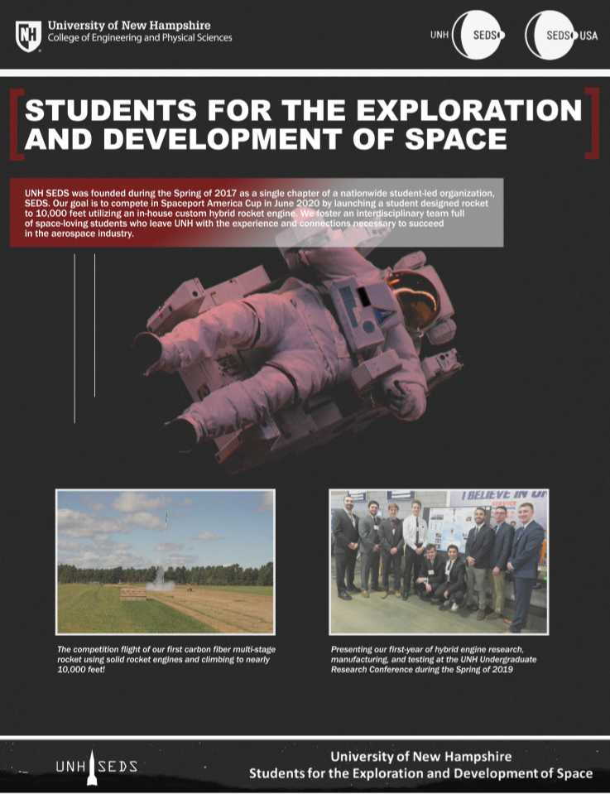

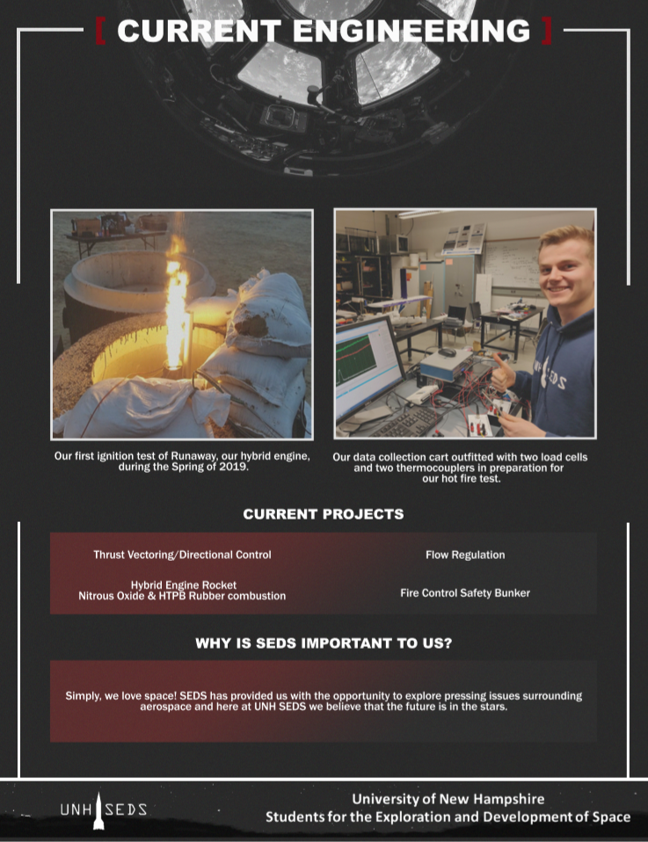

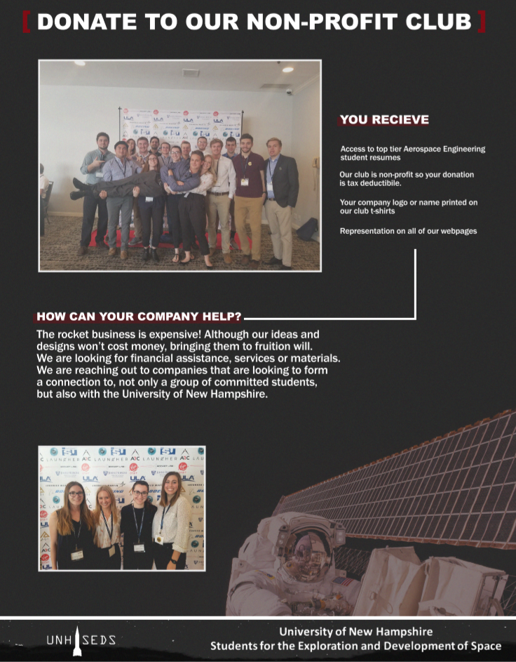

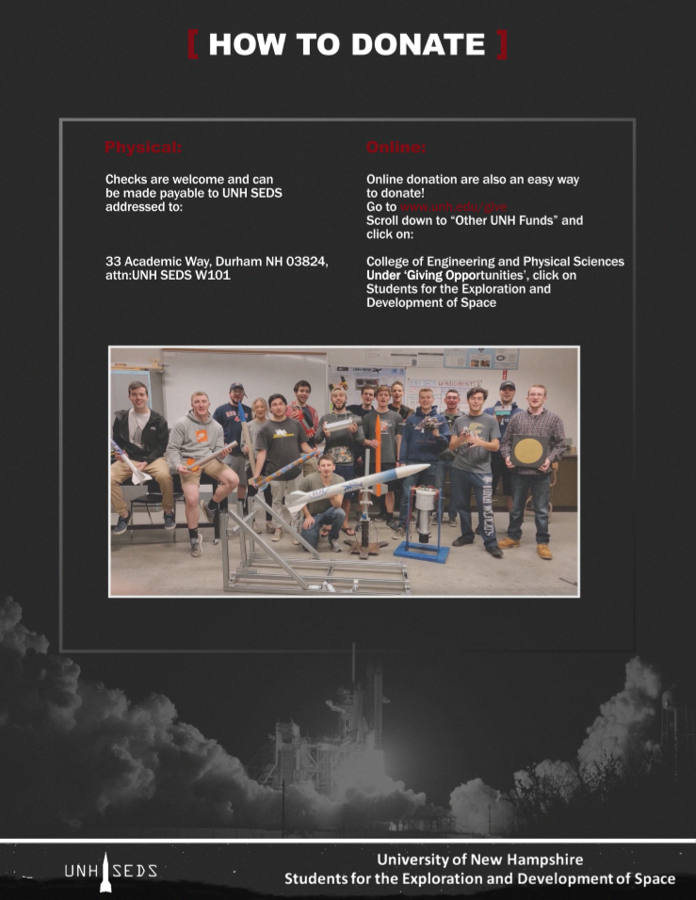

## Appendix F

The first finance incentive program



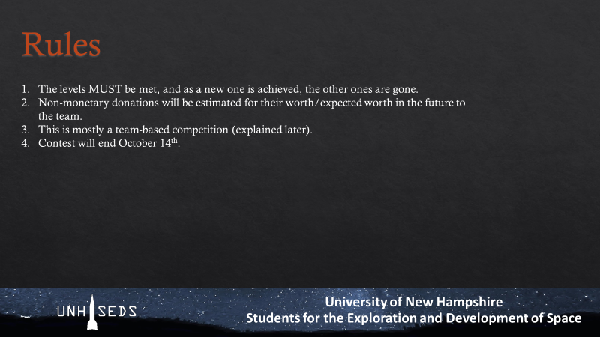

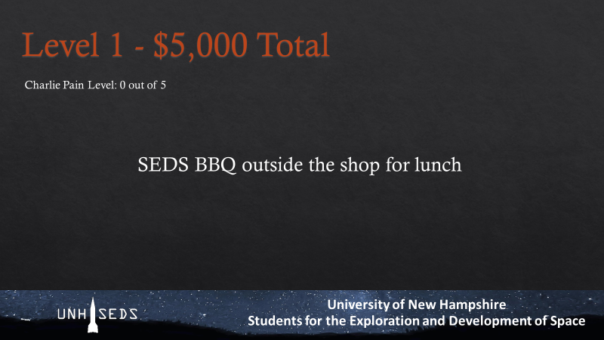

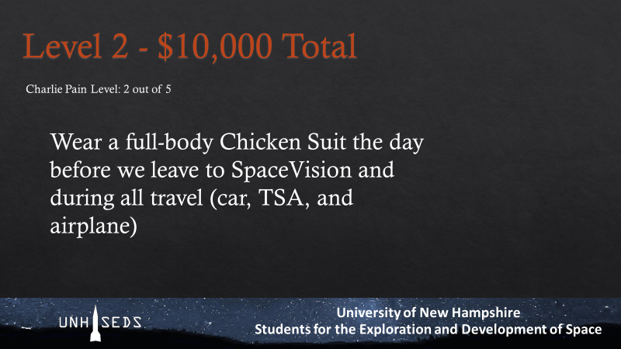

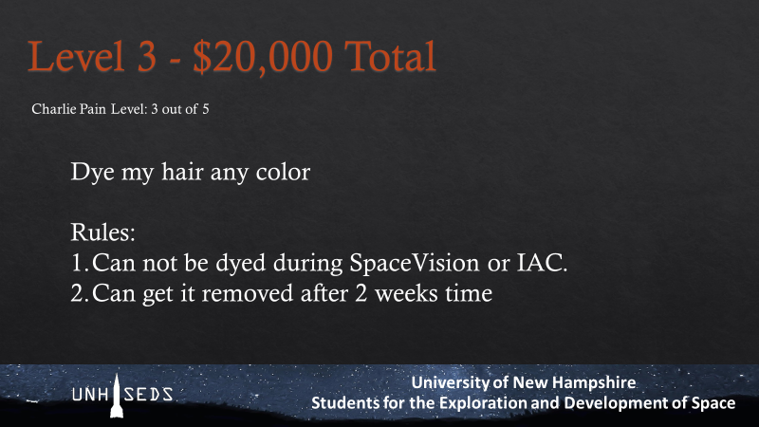

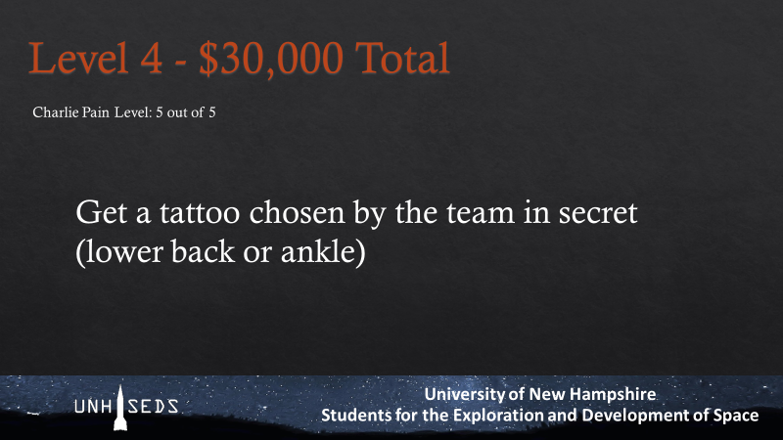

## Appendix F

The progression of logos for UNH SEDS.

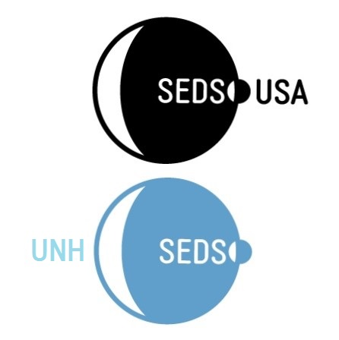

Figure - UNH SEDS' first logo



Figure - UNH SEDS' second logo



Figure - UNH SEDS third Logo

## 